119
Apart from this one, the most used road was the road to Coarraze whose pitiful state was already the concern of our municipal officials before and during the Revolution. Several projects of installation had been decided between 1780 and 1790 without bringing a satisfactory solution. It was necessary, moreover, to pass the brook of Sacq on a wooden bridge through which one was likely to fall on each voyage! It will be necessary to await the beginning of the century 19th to see the undertaking of serious work, at the same time by Coarraze and Montaut.
Why a factory of chapelets (prayer beads) at Montaut?
The first question which comes to mind relates to why this manufacture was in our béarnais village.
The presence of the boxwood, its exploitation and its transformation for centuries in the area is a first answer. Abundant indeed on the slopes of our mountains, the boxwood, provided for a long time the raw material for a number of usual or different objects (various combs, forks and spoons, buttons, jeux divers …) and it is at the origin of the manufacture of the chapelet.

The " chapelétaires "
The consultation of the parochial registers in which certain priests had the good idea to mention the trades exerted by their parishioners, provides us the proof of this production at Montaut about the middle of the XVII century.
A baptismal certificate of a Sérisseau child, of our village, going back to 1689 indicates the profession of the father: “chapelétaire”. Which could have begun about fifteen years earlier.
A little history says to us that he had a shop “at the end of the old bridge of Bétharram”.
As so many others he sold objects of piety; among those, chapelets manufactured by his fellow-citizens of Montaut.
Here thus marked the name of this high place of mariale devotion made to the “Virgin of the Beautiful Branch” towards which converged crowds of pilgrims for centuries.
Pilgrims and chapelets are often associated, second reason of the presence of this manufacture in our village.

The pedal turns (lathe) and hydraulic turns
The average mechanics artisanal used to create the pearls or the grains was the pedal turn for a long time, a rudimentary machine actuated with the legs (in the manner of an old sewing machine).
The work completed with this apparatus was not always of a high degree of accuracy; to actuate this “turn” throughout one day was to be rather tiring!
The technical progress made in the last century by the use of hydraulic power, employed to make mill turns, and the improvements “in the mechanics of

Chronique de Montaut
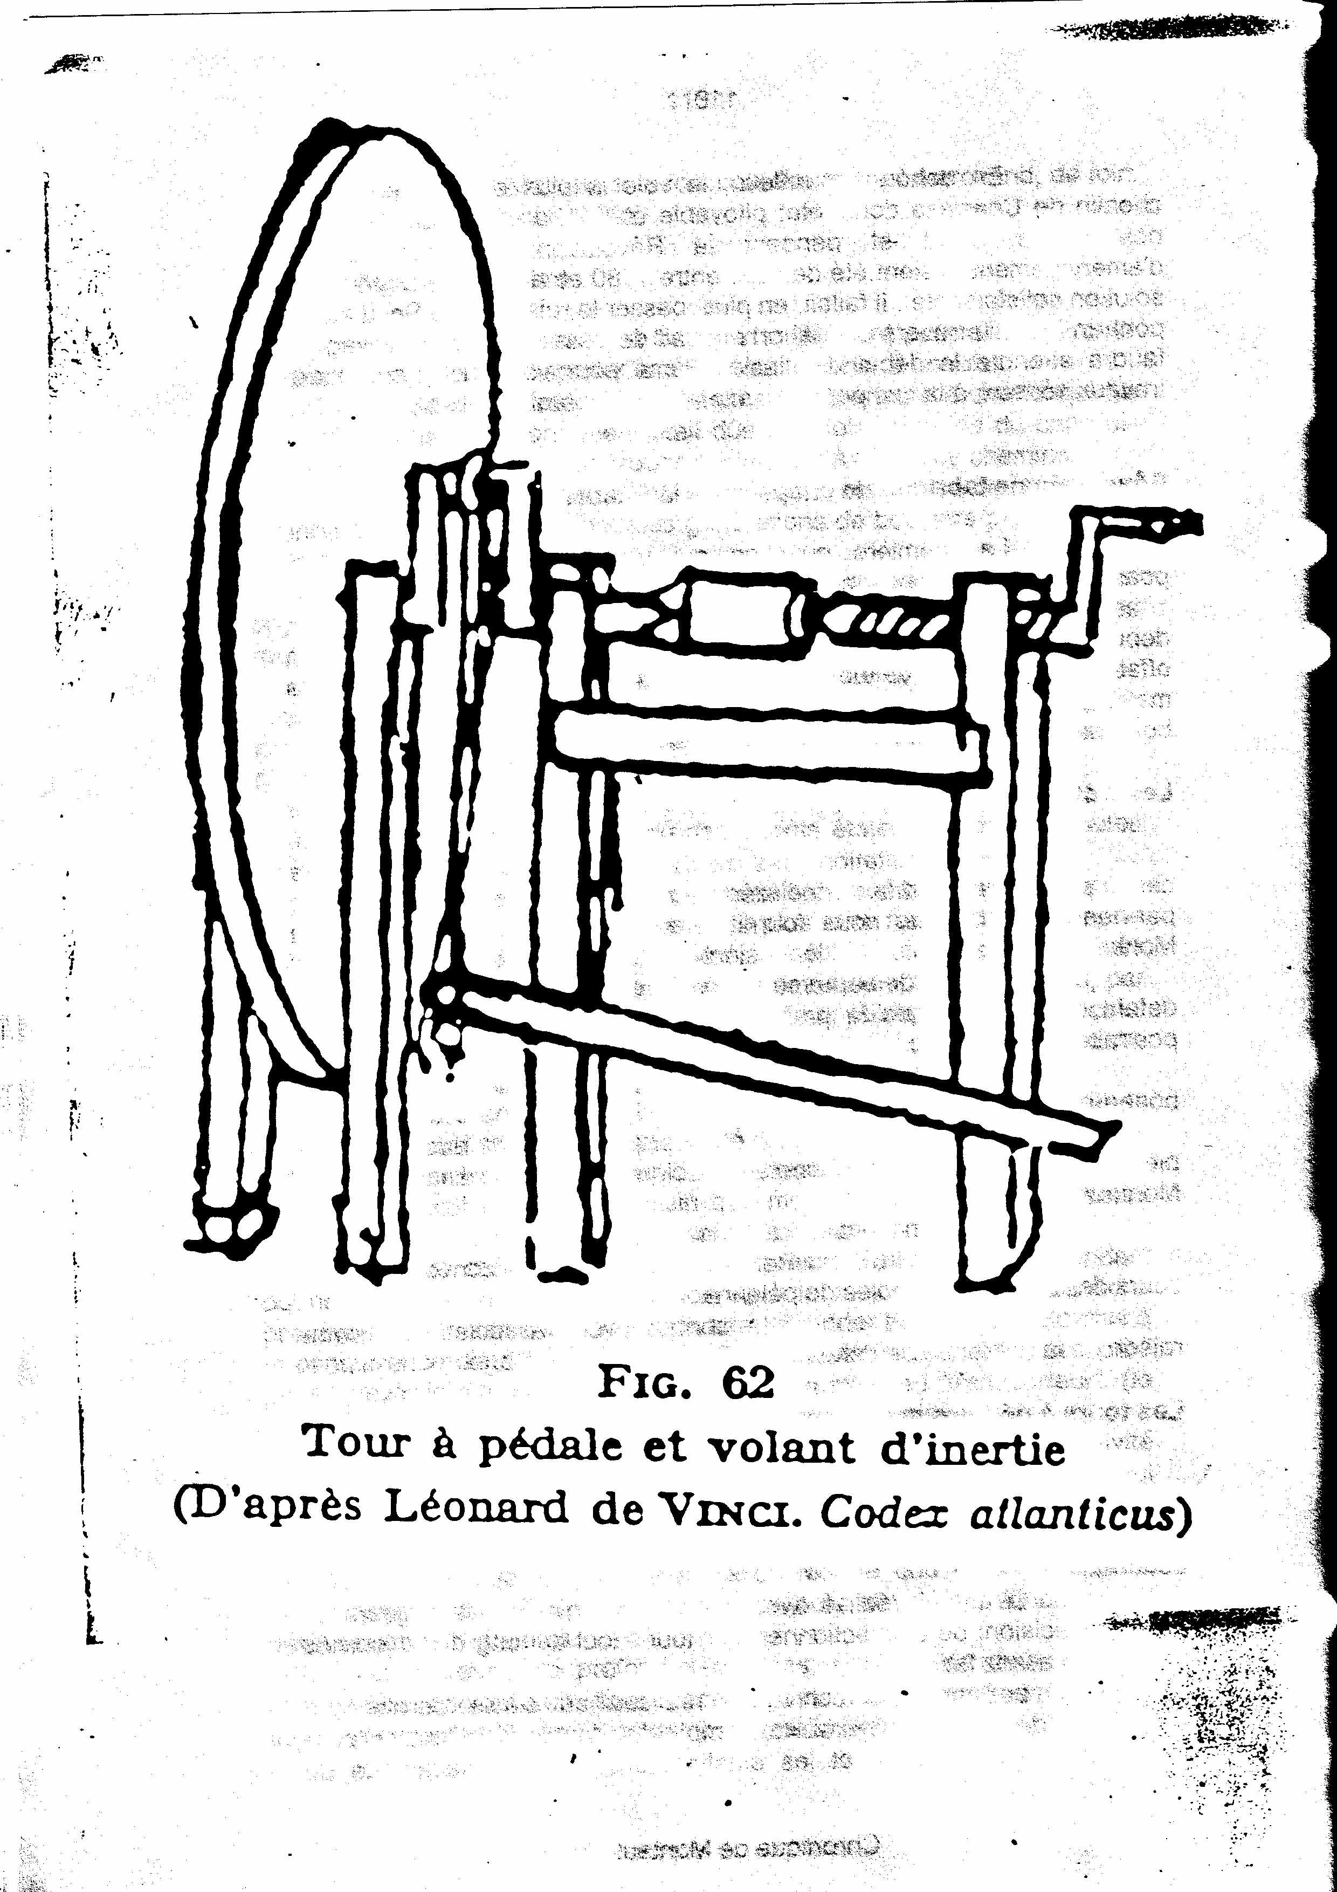
120
movement “made it possible to replace the pedals with waterwheels.
The geographical position of our commune, at the edge of Gave de Pau and its affluents, predestined it with the use of this energy.
This additional asset, indisputably contributed to the dynamics of the craft industry initially, then with the creation of a true industry thereafter.
Bétharram and its pilgrimages.
One could not tell the history of the chapelet of Montaut without speaking about this high place of devotion to the Virgin Mary.
The beginning of its monumental rebuilding, due mainly to Hubert Carpenter, in the first half of the XVII century coincided with the re-establishment of catholic worship in Béarn and the rebirth of the pilgrimages, thanks to the presence of “chaplains” who ensured the organization and the reception of the pilgrims.
Saint Vincent de Paul, the founder of the Lazaristes and the Sisters of Charity, wrote in 1659: “It is a question of an establishment of the Company, in a place of great devotion and if it is not the second, it is at least the third most attended in the Kingdom: it is Notre Dame de Bétharram where miracles are often done. ”
On his side, Pierre de Marca, referring to the Virgin of the Beautiful Branch, and his sanctuary, specified: “The people of Béarn cultivated with great care the honors which are legitimately given to the powerful and very Blessed Virgin Mary and built to her chapels like that of Bétharram. ”
We will not remake here its history, magistralement written, moreover by the Father Henri Lassalle and to which the Father Descomps knew to bring his personal note. More than two centuries before Lourdes, this great place of devotion and pilgrimages attracted crowds not only from Béarn and Bigorre, but also from the South-west and even the whole of France.
Of course, other mariaux sanctuaries, more modest, certainly, were born in our area, also attracting many pilgrims for whom the possession of one or more chapelets were the essential support, even the external mark of their devotion and their prayers.
It was thus necessary to provide for the request, of the always increasing faithful, in objects of piety. Added to this, the indulgences allotted by several Popes to the chapelets manufactured of “natural materials”, which the boxwood was, contributed to its “expansion”.
The history of the “chapelétaires”.
The first of them, installed in Montaut, as we saw, began its manufacture about 1660. Between this date and the first third of the XVIII century, we have little information.

Chronique de Montaut
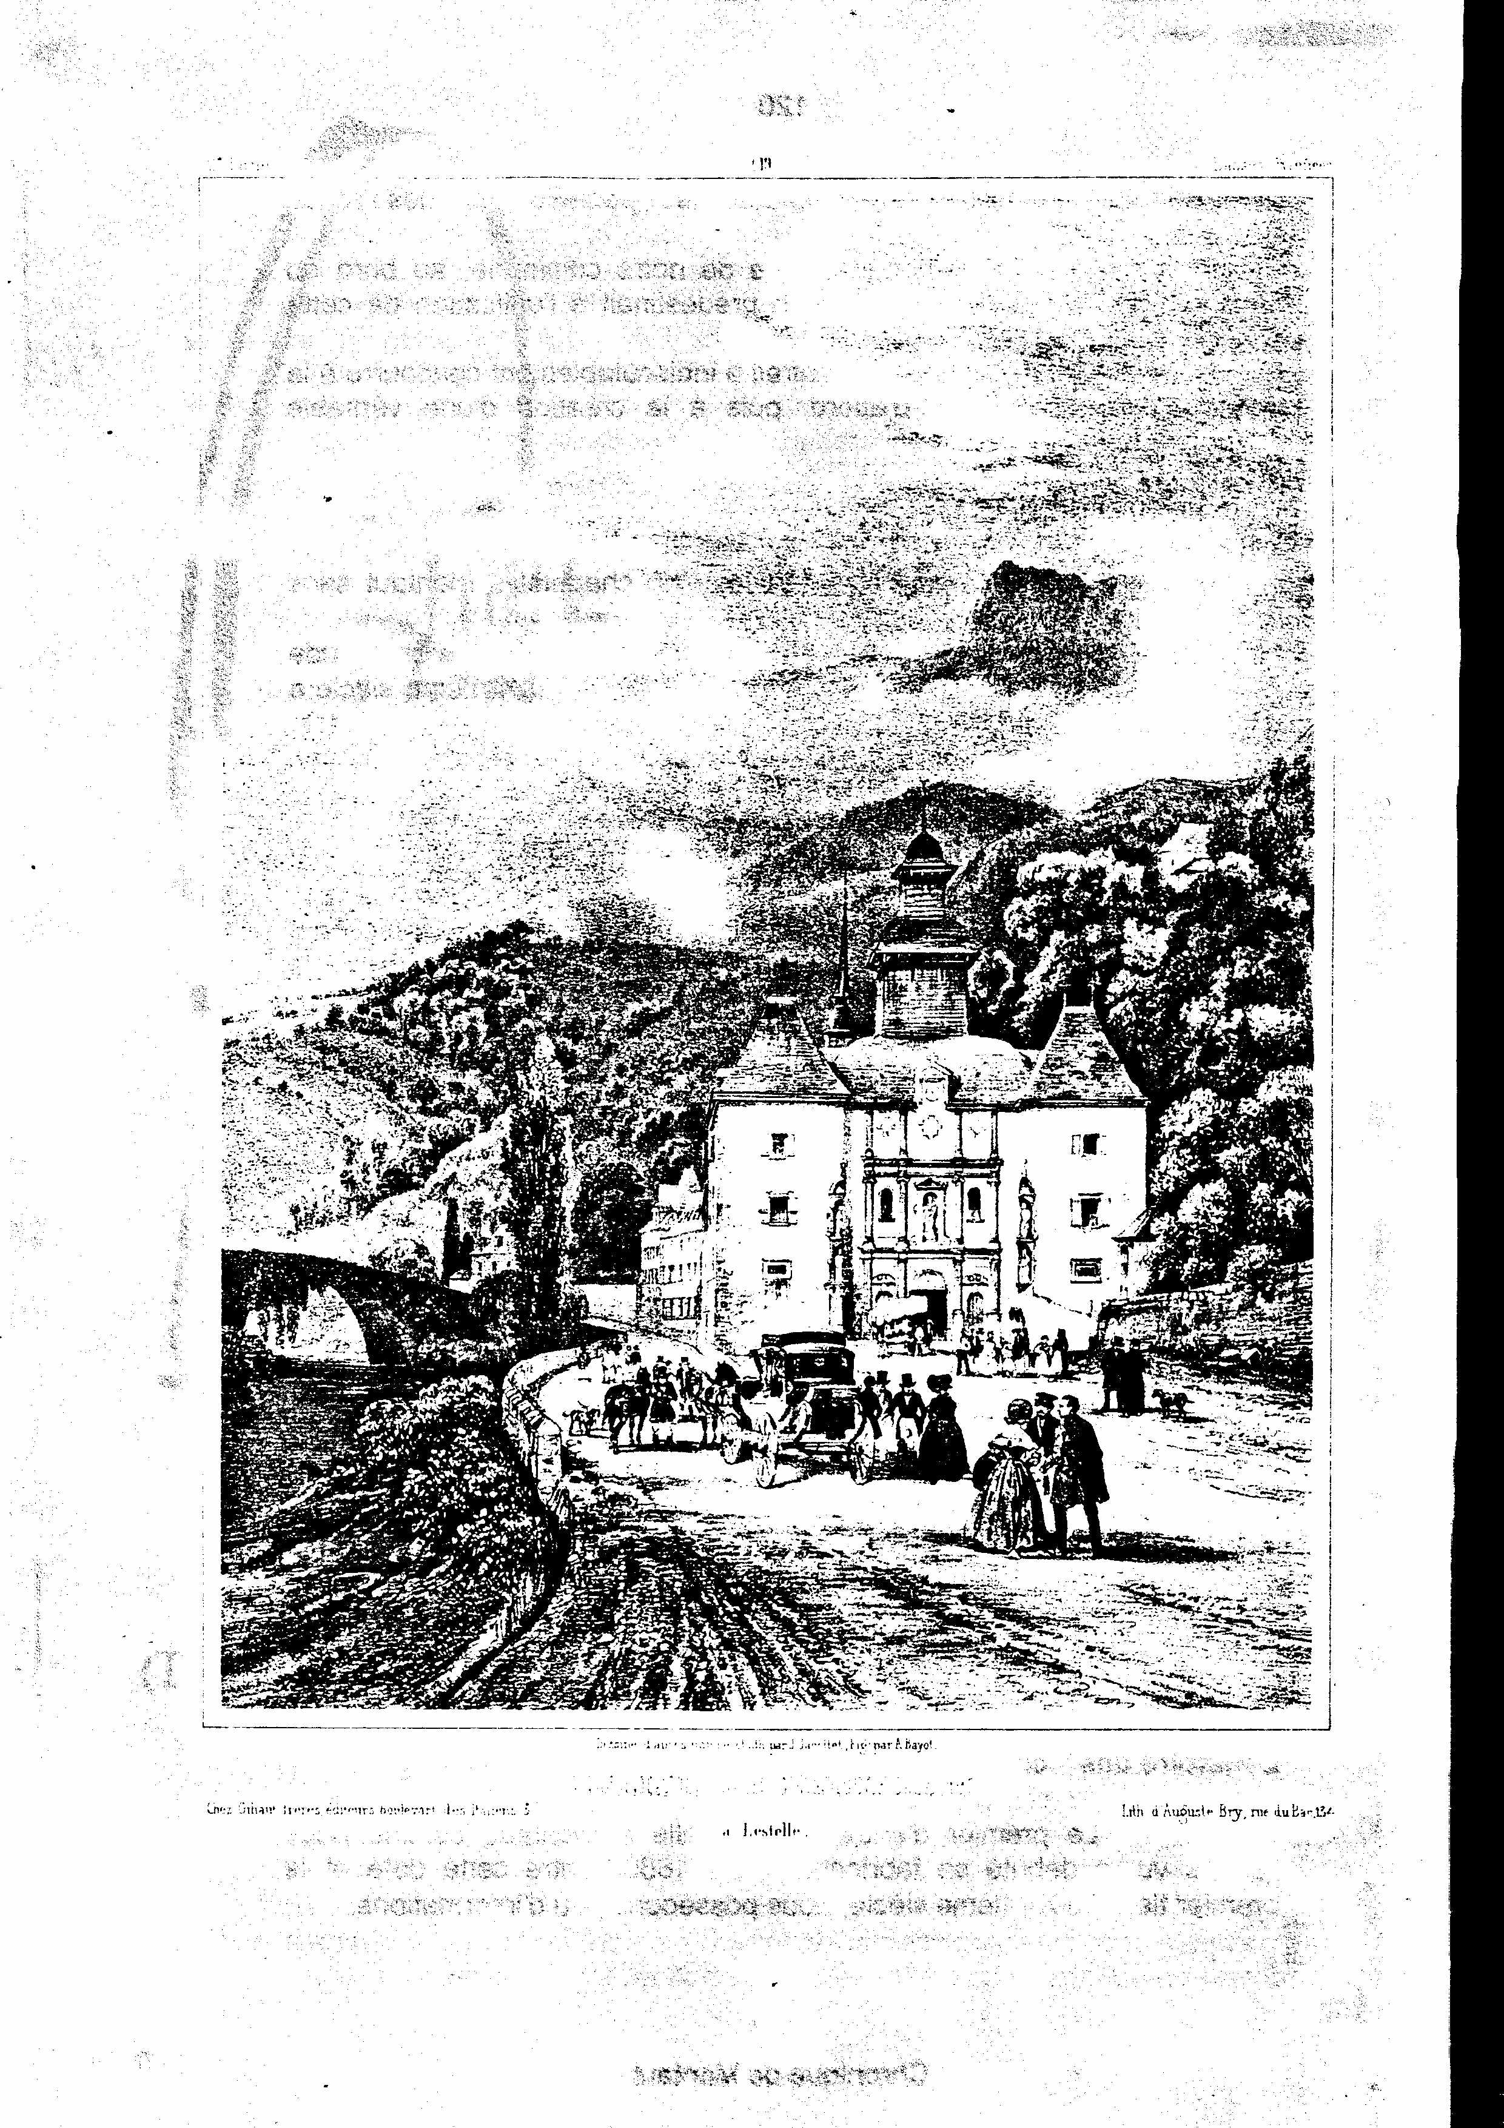
121
On the other hand, a list of witnesses to a lawsuit dating back to 1729 indicates their age and and their profession. We thus find eleven “workmen in chapelets ” in our village.
Plus, in another document is an extract of the register of the Parliament of Pau dated September 25, 1731 attesting the existence of forty shops of Bétharram in which, so many of the merchants of the place whom the foreigners employ in all kinds of goods of a number, like…chapelets. Besides this trade was in a cruel competition with the Sunday services of the parish of Lestelle. who, as stated in the same document were “deserted”.
To feed these various shops a certain production was needed to which would contribute to our fellow-citizens no doubt.
The years pass… the request of the objects of piety increases regularly and therefore, the number of those which manufactured them as stated in a document discovered in the archives of the commune of Montaut, titled “Role of Voluntary Contrubution” and about which we already spoke.
We could enter all the “chapelétaires” of our commune. They were thirty three!
Their number had tripled in sixty years. One can deduce from it that the request for chapelets had largely increased making it possible for a number of families to draw an income from it, often auxiliary, improving nevertheless the modest family budgets.
The trade of “turner or the chapelétaire” was often practised by father and son during several generations as attested in the parochial registers or of the registry office.
The relative importance of the manufacture, if it fed in priority Bétharram and its pilgrimages, fed well also other places of devotion, in Béarn as well as in Bigorre and well beyond, which represented potential “markets” whose development was to allow, for one enterpreneur to pass from the artisanal stage to the true industry.

Thomas Saturnin Navarre
This man would be Thomas Saturnin Navarre. Issue of one old family of béarnaise stock present at Montaut since the beginning of XVII century, he counted among his ancestors several notables. One of them was even “ procureur ” of the commune during the Revolution in 1791.
Bertrand, his father, born in 1782 followed the occupation of arms manufacturer or “arquebusier”, mentioned again in documents of registry office.
Accustomed to utilizing tools and machines, he will transmit to his son Thomas Saturnin his know-how and will be able to initiate him in the secrecies of mechanics. He had first gathered in a workshop, several craftsman-turners, in 1832.
Né en 1810, il s'est donc intéressé très tôt à la fabrication du chapelet, et comprendra vite tout le parti qu'il pourra en tirer, il s'attachera à apporter des améliorations techniques à l'artisanat originel. Dès 1838,
Born in 1810, he was thus interested very early in manufacture of the chapelet, and will understand quickly all the parts that he will be able to draw upon, he will attempt to make technical improvements to the original craft industry. Since 1838,

Chronique de Montaut
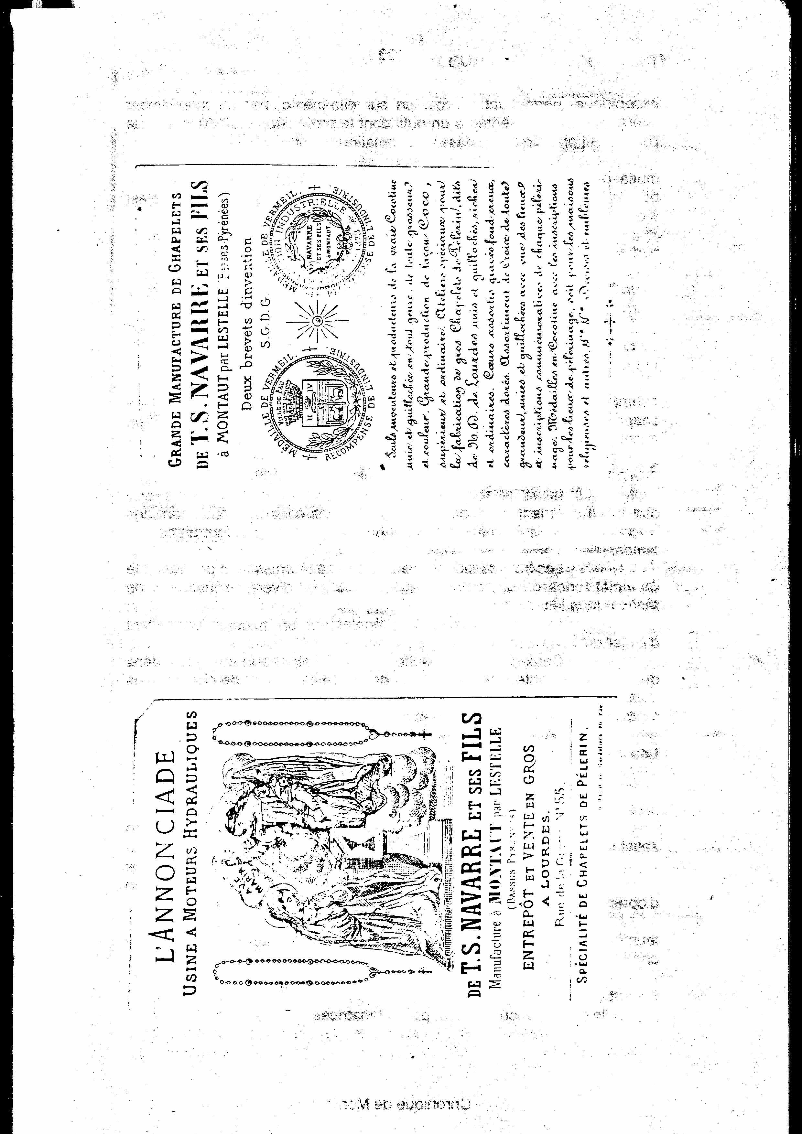
123
eccentric, allowing its rotation on itself, by a side movement he was presented at a tool whose profile depended on the reason that one wanted to obtain, then driven out automatically.
All the machines used for this manufacture were driven by hydraulic force. Each one of them had a double pulley, known as a “fixed” pulley or drive, the other known as “ folle ”, i.e. that it could turn without effect on the machine.
Horizontal timbers, driven by water turbines were placed in each workshop and were connected to each machine by a belt; a “walkman”, a type of forked metal, made it possible to bypass one or the other pulley, involving the start of the machine or stopping it.
The dyeing and the polishing of the pearls
The boxwood, in a natural state, is colored beige clearly, enough neutral but “not very commercial” in aspect of the “users” of chapelets of the second half of the XIX century and undoubtedly well before.
In order to give it “good looks” and to answer the taste of customers, it had to be dyed. The grains were soaked in a boiler whose liquid, made up of aqueous solutions containing natural or chemical dyes, was brought to boiling during a certain time.
The wood of campèche or Lima provided for example dark purple or a sharp red and the various mixtures made it possible to carry out all the colors.
The baths also contained a fixer making it possible to prevent that with usage the grains would not fade.
Those dryed with hot air were then polished in barrels containing a mixture of wax and sawdust. Actuated by a rotary movement, it turned a certain number of hours according to the quality of the brilliance and the desired polish.
The accessories of the chapelet
To supplement the manufacture of the chapelet, remained to carry out medals, hearts and cross out of boxwood.
The relatively reduced dimension of the grains could be satisfied in discs, in other words of boxwood cut out in the vertical direction. The diameter of the medals could not be satisfied of such a reduced surface, also cut out one this one in the direction length in order to obtain plates.
The medals were then pierced with three holes through their thickness in order to connect them to the other elements of the chain by a wire.
The hearts which played the same part as the medals were cut out with the saw, then bored in the same manner. As the grains they were then dyed, polished and matrices.

Chronique de Montaut
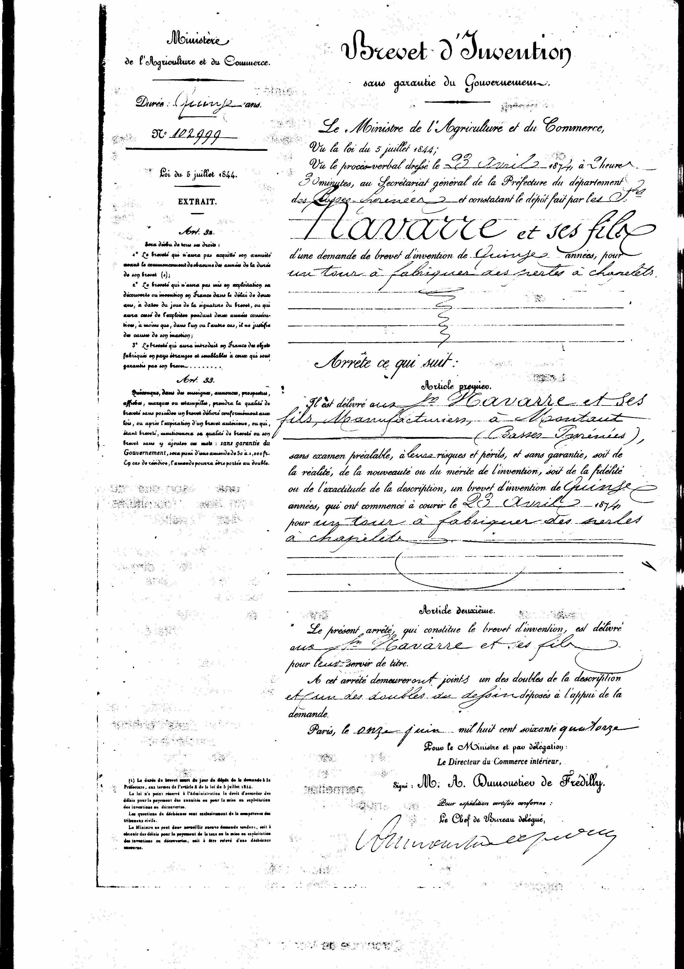
124
The metal matrices
Realized with the request in steel bars, they comprised in hollow or relief of the various texts or the representations of places (grotto of Lourdes) or of saintly characters.
There was a manner of personalizing the chains either according to the existing pilgrimages, or according to the pilgrims coming to request. Thus thry could be marked Pilgrimage of Doors, the others: Souvenir of the Pilgrimage of Marseille to Notre Dame de Lourdes etc…
The matrices could also be struck to celebrate the various appearances of the Virgin, or from the messages “drink of the fountain and wash there”
The sizes or forms differed, round, square or hexagonal, they made it possible to decorate at the same time medals, hearts or cross out of boxwood.
The assembly of the chapelets
It was at the last stage, to some extent the assembly of the various elements whose manufacture we follow step by step.
To carry it out, one used brasswire of iron or copper. In Montaut, as in Lestelle existed a house known as “of the chapelet” in which the supplies were stored (pearls, cross, medals, wire). Came to supply the workers in residence there. The first operation of the assembly consisted of threading the grains on a yarn of true hemp, in their final form, i.e. by intercalating” “a Lord's Prayer” all ten “aves”.
This work was often completed as said to us by the old ones to have done it themselves, or by children on their return from school. Tariffs were provided according to the number of tens that comprised each chapelet. The prices indicated here must go up at the beginning of the century:
- 0,20 Fr .per gross of chapelets of 5 tens
- 0,25 Fr. 6 tens
- 0,30 Fr. 7 dizaines.

Using special grips “aliquats” each worker cut and worked the wire by carrying through a loop at each end of the grain, making it possible to connect it to the precedent and the following.
If we take as example the large chapelet known as “pilgrims” the first ring allowed to hang the cross. Followed a grain fixed at the preceding ring by the wire, twisted at an end before its passage through the grain, then rounded in the shape of a ring at the exit to cling to the following grain. “Lilies of the valley”, small cylindrical parts of turned boxwood, came to complete the decoration.
Once the chapelets were assembled, the workers came to bring them back and set out again with new supplies.

Chronique de Montaut
125
The various shapes of chapelets
Traditionally, we are accustomed to reciting a chapelet made up of 50 “Aves”, grouped per tens, separated by a more coarse grain on which one recites the” Lord's Prayer “.
But all the chapelets do not comprise series of ten grains, not more than five tens.
Most known of all, the rosary (which had its vogue with Lourdes) consists of fifteen tens of 10 grains each.
Then the chain comes from Holy Brigitte whose origin goes up at the start of XlV century. It is divided into six parts, each one includings ten “Aves”, a “Lord's Prayer”, and a “Creed”, then, one recites a seventh additional “Lord's Prayer” and three " Aves”; one arrives thus at sixty three” Aves “. According to Holy Brigitte, this figure would correspond to the number of years the Virgin passed on the ground.
We find also the chapelet known as “of the seven pains” created in 1724 by Pope Benoit XII and composed of four series including a “Lord's Prayer” and seven “Aves” representing the seven pains of the Virgin.
One could still quote other shapes of chapelets. We will be satisfied to name lastly the Moslem chapelet because its manufacture, thanks to Navarre, knew a certain vogue in our village.
It is traditionally composed of 99 grains, grouped per series of 33. On each one of them one recites one of the divine names of the prophet. Islam in codified 99.
The piece of wood separating the series bears the name of “témoin” and a small turned boxwood reason: placed at the beginning of the chain “marabout”, (Navarre archives).
The assembly is carried out on a yarn of very resistant true hemp and without separation between the grains.
We wondered why Moslem chapelets had been manufactured in Montaut.
Let us say initially that if one sticks strictly to the grains, nothing differentiates them, some is their destination; what wants to say whether with same basic material one manufactures indifferently Moslem or Christian grains. Navarre, a dynamic man and entrepreneur was with the mounting very emerged again for its manufacture.
Maintaining relations, as his many correspondence proves, with Parisian purchasers those put him in connection with importers established on all the circumference of the Mediterranean.
They addressed orders to Montaut by asking whether this manufacture was realizable. If there was an affirmative answer, the orders flowed.
We found the cost of freight in 1904 from the station of Marseilles to Constantinople, 6,25 frs per 100 kilogs; in Jeddah (the port of Meca) 8 frs per 100 kgs. The departures took place every Wednesday for Constantinople and every 28 days for Jeddah. For Alexandria, 50 frs per ton, Port-Said and Syria 60 frs.
Chronique de Montaut
126

The chapelet, a true industry

When Thomas Navarre wrote to the Prefect of the department in 1838 to inform him of his projects, he employed about sixty workmen. The construction of a first factory in Bordou in 1854 enabled him to increase his manpower.
On February 11, 1858 took place at Lourdes the first appearance of the Virgin to Bernadette at the grotto of Masabielle. They will follow one another 18 times until August 27 of the same year.
Very quickly fame of these appearances and the miracles which occurred attracted a crowd of pilgrims for whom the recitation of the chapelet (moreover highly recommended by the Virgin) was a privileged prayer.
In front of the surge of the orders our manufacturer, who besides installing a warehouse at 55 Street of the Grotto, had to consider the construction of other workshops.
The improvement of the productivity was also one of his concerns and in 1862 he deposited a patent for a turn with punch, driller universal.
Several hundreds of workmen worked then in the manufacture of the chapelets.
The evolution of outlets
An engraving appearing in a devotional work of Brochon of the mariaux pilgrimages in France, a sight of Bétharram in the last third of the XIX century represents over which we clearly see the shops of the merchants of objects of piety as we can see on engravings of Memling or Jacotet.
The chapelets were sold in these shops. They were taxed with a right of “placage” whose amount varied with the site compared to the chapel.
A tariff dating from the end of the XIX century indicates to us that for the festivals of August 15, 8 and September 15, the tax was 1 franc per day for the merchants of chapelets and of 0,50 franc for Sundays. These taxes were perceived with the profit of the commune of Lestelle.
It is undeniable that the apparitions of Lourdes and the pilgrimages which followed from there brought their share of development.
The first name of Manufacture was L'Anonciade factory hydraulic engines. The chart, found in our files, indicated: “Special workshops for the manufacture of large chapelets of pélerins”, known as “Notre Dame de Lourdes” plain or guilloched, rich or ordinary, matched hearts, engraved hollow bottom.”
These large chapelets which one still finds today knew their years of vogue and were manufactured not only for Lourdes, but also for a certain number of wholesalers into objects of piety which had known very early to appreciate the important success of this article.
The inscriptions raised as well on the matrices of cross, medals or hearts, are as many sources of information on the dynamics of the pilgrimages in France in this second half of the XIX century.
Chronique de Montaut
127
This one thus played a major part in the evolution of the outlets; the study of the files confirmed it to us. In our current materialist world, one forgets how much the religious feeling was long-lived in France, particularly in the last quarter of the XIX century.

The export of the chapelets
If France of the pilgrimages and the wholesalers into object of piety represented a significant part of the markets, very early, the foreigner, thanks to the mutilple contacts made by Navarre at the occasions of expositions, also ensured the flow on the other hand of his manufacture.
Pilgrimages in Spain like that of the “Virgin del Pilar” in Saragossa or in Italy as “Notre Dame de Lorette” attracted crowds of pilgrims consuming objects of piety, therefore also chapelets.
Navarre had also developed a whole network correspondents both in Europe and in the world, which placed to him important orders.
Switzerland, by the entremisf of the Benzigef family specialized in the trade of “objets of art of devotion” represented an important market. In addition, this same family having houses in New York and Cincinatti was remarkably placed to open the United States with the béarnais products.
Other outlets were done daily in Germany via Cari Poliath, installed in Bavaria, which ordered by hundreds of grosses (we found in the files the orders of more than 700 grosses, that is to say more than 100.000 chapelets).
As well Luxembourg as in Belgium, in Spain or Portugal, a solid commercial establishment made it possible to ensure the regularity of the orders.
We even found cllients in Brazil (Rio de Janeiro), in Cuba (Pedro Masedo at Havana). We could multiply the examples like this.
This policy, because we can speak about a true marketing policy, speaks of the markets external to France was well in the character of Navarre, an entreprenur, not hesitant to travel or arrange travel for the collaborators to sell their products.
In that, they made, in their trade, original works of their time and were certainly the precursors.
Their dynamism made it possible to make Montaut the small capital of the chapelet, while creating, a true industry, giving work to several hundreds of workmen divided in various places of production and to many home workers.
Trusting in the quality of their products they knew to carry high and far the reputation of the montaltois chapelets.

Chronique de Montaut

