111
It was the case of the lime manufacture, almost thousand-year-old craft industry, that of the chapelets, since the XVII century, that of paper since the XVIII century.
The evolution of certain manufacturing methods had already been born since the first third of the century by the regrouping of craftsmen in a workshop of wood turning. The manufacture of paper, containing rags gave work to some companions in a factory “with simple battery”.
It is necessary nevertheless to await the last third of the century to provide these " first quiverings to pass at the higher speed and to become, under the impulse of “contractors” true industries.
With the origin of this evolution, we find men who will have known to show dynamism and entrepreneurship. It will be, for example, Brousset-Matheu for lime, a Baron for paper, Navarre for the chapelet and the buttons.
It seemed to us interesting to place at this place of our chronicle the respective stories of the evolution of each one of these companies which largely contributed to the reputation of our village.

The manfacture of the lime
Also far one goes up in the time, it seems that he belonged to the ancestral inheritance of our village, since, during the demolition of the last vestiges of the chapel Saint Hilaire de Lassun, ruined at the time of the wars of religion, but built at the dawn of our century, the mortar which bound some remaining stones was made of sand and lime⁴⁹.
One also knows that for the construction of the church of Pontacq, set up in 1511, called upon the lime of Montaut, as for the rebuilding of the chapel of Bétharram at the XVII century; one indeed finds the number of lime tanks in the accounts of the treasurer.
It is also known that in 1633, the chaplains perceived a royalty of 12 sols on each lime kiln.
Lastly, the role of the patrioric contribution of 1790 comes to bring the proof to us of the economic part played by manufacture and the trade of lime in our village until the first third of our twentieth century. But why lime of Montaut?

The careers
The geology equipped us with an important specific limestone vein for this manufacture.
Compact, gray more or less dark, with calcite veins, this stone levels by places or form on the contrary an eminence which can reach, as with the career of Castera located on the road to Mourle, 15 to 20 meters in height.
The exploitation of the careers was regulated, as well on the communal level as on the prefectoral level. In the first case, a tax was perceived on each extracted stone tank and came to feed the communal budget; as the prefect, gave him the authorization to exploit.
Chronique de Montaut
112

The extraction
It was about a painful operation reserved to the miners. In Castéra, installed on scales suspended with cords to enable them to be driven along the coal face, they attacked this one by the top using a graver (the grip) and of a mallet (two-handed hammer).
In order to drill a hole in the stone, the miner gave a quarter of turn to his graver with each blow of mallet to ensure a regular progression this one. The dust, generated by this operation of drilling was removed progressively using a narrow spoon with a long handle.
When the hole had reached a certain depth, 60 to 80 centimetres, the miner installed a wick, stuffed with powder initially, ground then, lit and put himself at a distance, at the time of explosion.
The rock thus “torn off” was presented in various quantity and stones of any dimensions. They were then sorted.

The communal royalties
At the beginning of the XIX century, the mayor and his advisers made a decree (October 6, 1815) regulating at the same time the mode of exploitation of the careers and the price to be paid for the extraction of the stones.
The measuring unit selected was a function of the capacity of the charges of the various loads:
- for a batch of 30 tanks, the royalty was of 6 francs
- for a batch of 25 tanks, the royalty was of 5 francs
- for a batch of 20 tanks, the royalty was of 4 francs
that is to say an average royalty of 20 centimes per tank; doubled for the foreigners not of the commune.
If one estimates at 120.000 tanks the production of the carrier during the 45 best years of production, the royalties represented approximately 24.000 francs.

The cooking of the stone
Once the stones were loaded in the oxcarts by the carrier, they were transported to the accesses of the furnaces. The operation of loading, installation of the hearth intervened then, firing and cooking of the stone.
Two processes were used:
- one, very old and artisanal, constituted the cooking of the stone in furnaces heated by wood.
- the other, dating from the last third of the 19th century, allowed to obtain lime much more quickly, in quasi industrial quantity, the furnace with continuous heat, fed with coal.
(Brousset-Matheu, Clos, Baylou...)
Many a montaltois followed with interest and sympathy the realization, on the initiative of one of their teachers, Vincent Signes, by the young people of the center Saint George: handing-over the operation of a lime kiln in April 1994.
Chronique de Montaut

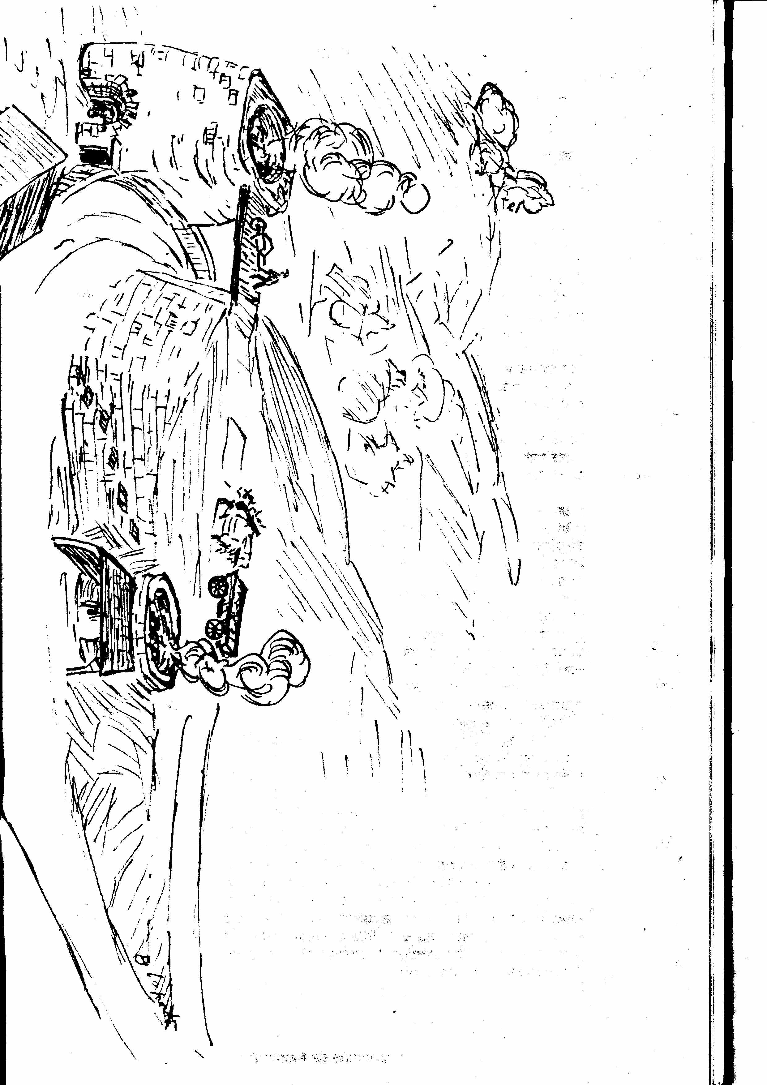
113

Furnaces with wood
The construction of a furnace, works collective to which took part chauffourniers and neighbors, (pilot those whose ruins remain along the road to Mourle) was in general carried out on land located on the edge of the road. Often it leaned with the slope of the ground on one or several sides ensuring in this manner a greater resistance to the load.
There could not (in general) be some discussion about using stones limestones for its construction; under the effect of heat, they would not have resisted. One thus used stones more resistant exits of the close careers. The heat released by successive cookings damaged the furnaces, obliging their periodic rebuilding.
Brought by the carrier by oxcarts, the stones were stored near the furnace; long “leagues” or stones being used to form the vault of the hearth, a side, the “whole coming” from the other. This one was often to be broken with a special hammer. To build the vault of the hearth, called upon a man of experience.
Indeed, on the solidity of this one the success of the operation depended on transformation of the stone into lime. If, by misfortune it came to break down in the course of cooking, the stone badly or insufficiently cooked were not usable, wasted money and time.
It took approximately a eight hours to charge the furnace.
Well before this operation the collection of the wood took place from " edges of meadows " or of wood coppice resulting from the forest of Mourle. More wood was dry, better was combustion, therefore released heat.
Once lit Monday morning using brushwood and often of charcoal; one fire well off, it had to be activated throughout the week. With this intention, one acted on pulling using a stone sliding punt which blocked or increased the air flow according to its displacement.
Fire was thorough at the bottom as of Monday, then gradually brought back. As of Wednesday, the fire led to the maximum cracked the stones releasing a nauseous smoke until Thursday evening. At this time, to ensure the success of the operation, one was to see the flame above the furnace and smoke became white, then disappeared.
A “cooking” under good conditions required the presence of the men, during one week, day and night. Also they took turns every four hours, by teams of two; one approached wood, the other, using a special fork, was to push it inside the hearth and to spread out the embers.
Sunday, all the openings were closed, one stopped the door with a lump of earth so that the air does not pass and one covered the furnace in order to protect his contents from the bad weather.
One then let rest three days before drawing lime.
The consumption ratio of wood/lime obtained was 1,2 to 1,5 stere per quintal.
Chronique de Montaut
114

The furnaces with continuous heat
In front of the important increase in demand for construction, the method of cooking of lime with wood, slow and painful, did not make it possible to produce industrially.
One thus employed another process by using more important furnaces heated by coal.
The furnace Brousset-Matheu, on the road to Mourle is of this type.
The important solid mass of masonry of almost square form, a 9 meters height and a diameter of 4 meters, with walls of 1m80 thickness, was built of good stone. The interior, of perfectly cylindrical form, was entirely covered with refractory bricks able to support the important heat released by the combustion of the coal.
A road arranged in an inclined plan, starting on the left part of the road to Mourle in direction of Castera, allowed the tanks of stone to reach the summit height of the furnace and to discharge their contents in the vicinity.
A footbridge connecting the place of storage to the top of furnace (footbridge intended to span the road) facilitated the alternative payment of the coal and stone wheelbarrows. The power supply of the furnace was carried out uninterrupted. Lime was collected at the base of the furnace, crushed, then filtered, was then put out in bags bound for the customers.
Brousset-Matheu was a man full of ideas. With the back of his farm, on a level higher than that of his factory, he had built a basin supplied with several sources, of which that of Escabourous, and made up a reserve of water closed by a dam. The low point of this left a pressure pipe towards the factory located downwards, the hydraulic force allowing of entrainer either a bruising mill, or bluteuse with lime.
The coal used in his furnace arrived by coaches. It came from the port of Bayonne imported from England or Poland.

The authorizations of exploitation
The requests for construction and exploitation of which we are informed are the proof. Addressed to the prefect, they were supplemented by a visit of the Guard General of the Forests which wrote an official report of recognition.
The mayor, solicited by the prefectoral authority, was to also deliver his opinion and to supplement the investigation; he thus received the following letter:
The sieur X of your commune requested the authorization to cook lime in a furnace established a distance prohibited in forests. While this request is studied under the forest report in the interest of the petitioner, to proceed following the formalities prescribed under the inconvenient report. Please thus cause one
Chronique de Montaut
115
inquire “of control and inconvenienced” by deferring you to my circular of September 26, 1835 inserted into the collection of the administrative acts. As soon as the official report of this operation takes place, you will take care to transmit it immediately to me.
The mayor proceeded to the investigation without delay, in general in ten days and concluded his report by an annotation concerning the morality and the financial circumstances of the interested party! Much longer was the production time of the prefectoral decree. Thus, a request dated from the beginning of May 1836 saw its positive conclusion only at the end of the same year.
This resulted in an official document authorizing it petitioner to put his furnace in activity over one year, term of which ended in a new request for renewal was to be addressed to the Prefect.

Private furnaces, leased furnaces
The majority of the furnaces were exploited directly by their owners; some nevertheless, either that they were built on communal grounds, or which they are property of the commune, were leased.
It was for example the case of the furnace of Greenhouses-Bassots whose fate is regulated during the meeting of the council of February 13, 1852.
Laurent Aris, mayor, states to the district that Greenhouses-Bassots is a furnace not leased used by the chauffourniers of the district without the commune drawing the least return and that, if it were put in farm, it could increase the resources to them.
The council thus decides to lease it, after prefectoral authorization, for a six year lease, after adjudication.
The set price is fixed at 10 francs for each of the six years and payable on January 1 of each year by the contractor to the hands of the municipal collector.
This decree moreover stipulated, that he would be able to deposit in a perimeter of 50 meters all wood necessary to his activity.
He would be held to maintain the furnace in good condition and to carry out repairs with stone, lime and sand.
Another project (deliberated on June 18, 1871) discussed as a council and confirmed by a prefectoral decree of August 4 of the same year relates to the concession of a farming lease profiting the siuer Simon Baylou, with the help of the annual price of 200 francs, of a communal ground of a capacity of 450m2 located in the district of Castéra. It is also expected that, on this ground, the chauffourhier is authorized to build a hangar intended to preserve lime having to come from a furnace with continuous heat which will be built on the same ground.
This hangar had been the subject of consideration in the prefectoral decree which specified: that the lime kiln having to be continuously in activity will produce an enormous quantity of lime which could not always be easily output and that the petitioner will have inevitably to put it in storage.
Of course Baylou had the obligation to take all his stones to the communal carrier at the cost of 20 centimes per tank. In
Chronique de Montaut
116
1880, he extracted nearly 2.000 tanks, that is to say approximately 2.000 tons of stones.
The labor employed
Which labour was employed with the lime manufacture? It is difficult for us to answer with precision and the testimony of old could not enlighten us satisfactorily.
We thus sought other sources. The “Satistique générale'des Basses Pyrénées” by Picquamilh, dated 1858 indicates: the lime manufacture occupies approximately 30 workmen. The lime of Montaut enjoys a great reputation in the country.
Taking into account the importance of the production, this figure appeared rather weak to us; the number of operations to be realized (pulling up of the stone, transport to the furnaces, loading the furnaces, maintenance of fire, blutage, bagging and transport, to speak only about principal) was to provide work to a manpower definitely higher than, for our part, we will evaluate to around fifty in second half of the XIX century, at which time the use of the furnaces with continuous heat allowed a very important increase in production.
Working conditions, as in many industries of the time, were painful taking into account the heat disengaged by the furnaces and from the lime dust which attacked the lungs. It was specified to us besides that for the most arduous work, one employed the Spanish.
The utilization of the lime
Produced in our commune since the Average Age, it had always, seemed a double utility.
If the agricultural destination were certain, even important at the origin, it was used as an amendment to the soil at a time when artificial fertilisers did not exist, it knew a relative decline in the last third of the XIX century.
On the other hand, a major element of construction, it was at the origin of its rise.
The study of the notebooks of the guards of Montaut, concerning the extraction of the stones, makes it possible to draw a parallel between its increase and the realization of the construction of buildings or structures.
The majority of the houses of our village, the construction of the church and the town hall of Saint Vincent, supporting the works during the construction of the Bayonne-Toulouse railroad, in Montaut as well as in Saint Pée, the first part of the construction of the Boulevard of the Pyrenees, the bridge of July 14 and the hotel de France in Pau, are only some examples of the use of the lime of Montaut.
The contracts of supply
Until the end of the XVIII century it seems that the law of supply and demand freely governed the relationship between lime manufacturers and their customers or between merchants and manufacturers.
Chronique de Montaut
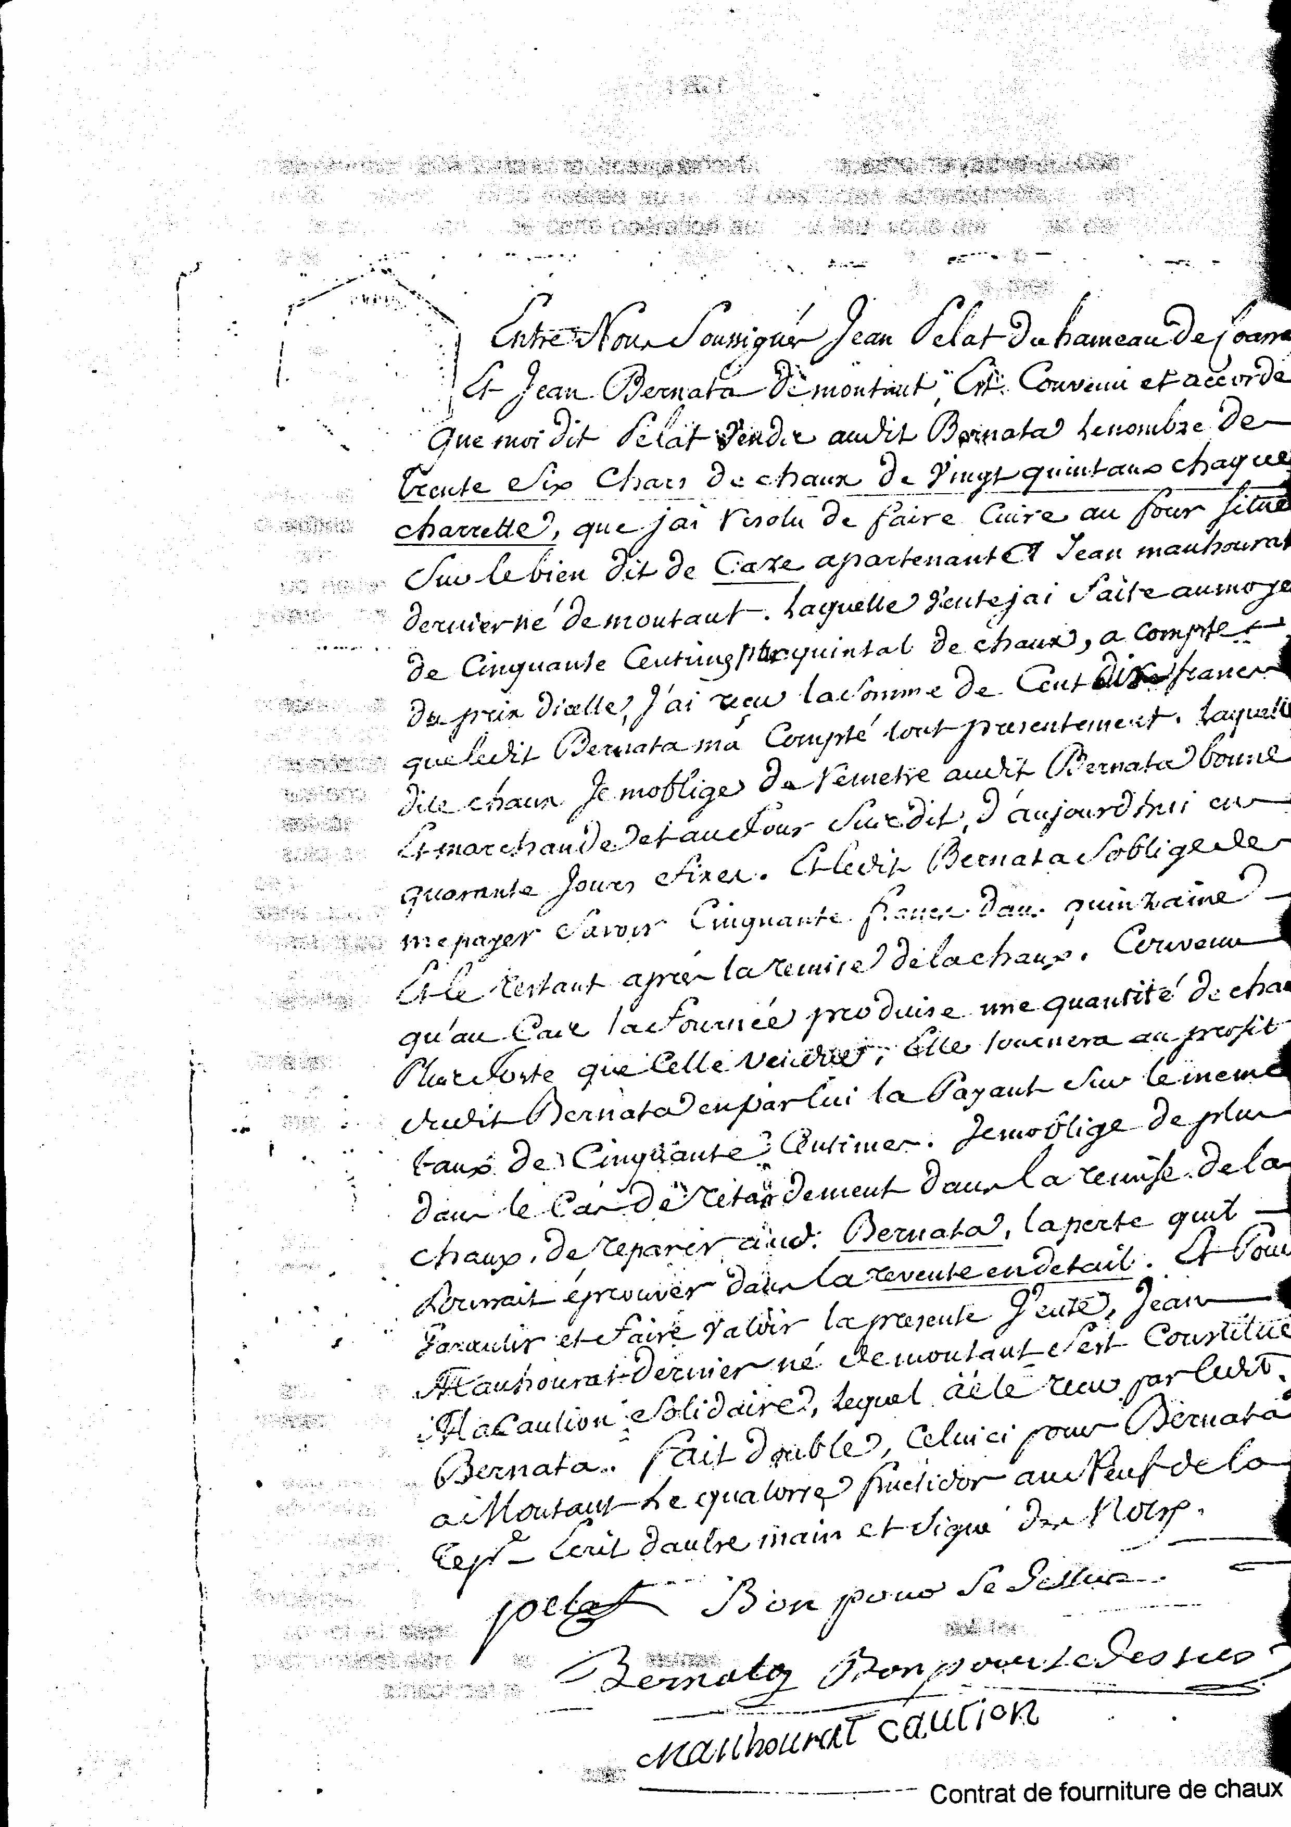
117
This assertion is based on the fact that the oldest contracts to supply lime on which we could put our hands, are a little after the beginning of the Revolution.
Here, for example, are the contents of the last contract of 13 fructidor year IX of the Republic between Jean Pelât of Coarraze and Jean Mauhourat of Montaut:
We agreed to make cook in company and to divide by equal portions the price of a batch of lime from here at forty days in the furnace of the aforesaid Mauhourat, the last born of Montaut, located on the aforesaid Caze.
Where the aforementioned Mauhourat is held to provide to tear off the aforementioned stone necessary to the aforementioned lime and to bring it near the furnace.
For work related to the loading of the furnace, he will have to provide four days and a day with oxen and charette for the transport of the stone. The said Pelât will provide all wood, large as well as small, necessary to the cooking of lime. Mauhourat will transport half of all wood to the foot of the furnace and will provide for the cut of glazing bar, two men until there is enough wood of this nature and Pelât, two others, each one of us will nourish respectively.
Being appropriate that for the cooking of lime each one will pay and nourish a chauffournier.
Still being appropriate that surïe peix which will be withdrawn from lime we will let pass a lime tank to that which will buy it in block, which will make two tanks for each one. And those which will state to have received the price from them will be released from his half on the total product. At the present it was made double.
Another bearing contract on a more important supply since they are 880 quintals (Béarnais), either 440 quintals metric esf negotiated on the basis of 56 centime per quintal, or 112 centimes per metric quintal, the total market being of 492,80 francs.
Lastly, another convention passed between a sieur Jean Siot, supplier of lime and Jean Brousset, lime merchant, bearing on 30 tons, with the help of the sum of 150 francs, envisages a mortgage required by the merchant on part of the goods of the said Siot as long as the totality of lime will not have been delivered! One holds is better…
Chauffourniers and merchants
According to the notebooks of the guards of the communal carrier of Castera and for the year 1826, 38 inhabitants of Montaut “uprooted” the limestone stones to cook them in the 28 furnaces in exploitation in the commune.
2.857 stone tanks were left the carrier and were cooked by Chauffourniers: Artigau, Basse, Baylou, Bernata, Signes, Boue Grabot, Bourdet, Caoussade, Casterot, Courtie Maupas, Cuyalou, Dagette, Hurou, Loustau, Maupas, Malaganne, Manaoutou, Mongay, Palisses, Pasquine, Plaa, Prim, Peyrounat, Sanchou, Seuque, Tisné, Vignau, to obtain approximately 2.000 tons of lime.
To realize the "rise to power" of the production, in 1880, for the only carrier of Castera, one passes to 4.500 tanks of stone, which gives the equivalent of 5.625 tons lime without counting the production of the private carriers: Prim, Marrouquet, Bernata, Aris, which largely came to double this figure, which is confirmed by
Chronique de Montaut
118
accounts of Brousset-Matheu, at the same time chauffournier and merchant, by far the most important of the commune.
The herdsmen and the tanks
The only freight vehicle used as well to go to seek the stones to transport lime was the oxcart.
Its average load was a little more than a ton. The relative reasonableness of the loading was due at the same time to the weight of the tank itself, various frictions (wheels, axles) and the state of the roads.
The importance of the manufacture of the lime trade gave rise to many generations of herdsmen owners of their attachment.
He needed a solid health doubled with good physical resistance to traverse day and night and at all times, the roads of Béarn by leading his attachment.
The distances covered, taking into account the slowness of the animals represented several tens of kilometers, therefore of long days which began well before sun up and finished after the sun set.
The most frequent destinations were Pau, Soumoulou, Morlaas, Lembeye where deposits were installed and all localities of the district of Pau.
The elevation of the routes comprised many coasts for which a simple pair of oxen, far stronger than cows, did not suffice. For this reason, the herdsmen left in convoy. Arrived at the bottom of the coast of Lagos, for those which went to Soumoulou, for example, one uncoupled a tank in order to harness two pairs of oxen to that which assembled the coast. Once arrived at the top, one repeated the operation for the other tanks.
The old ones which held this anecdote of their own parents, told us that near certain “grimpettes” like that located at the bottom of the château of Coarraze before its current installation, one called upon a neighbor who, realising gratification, lent a pair of cows to help to cross the obstacle.
The cost of transport was freely discussed between manufacturer or trader and purchaser. It seems that the majority of the transactions envisaged the delivery to the recipient user of lime. Subjected to the competition of other producers, the trader could “draw his prices” to remove the market and then requested an effort from the “transporter” (the herdsman and his pair of cows) and one shared the remittance.
With the statement of testimonys collected, this professional activity asked more sorrows and efforts of those who practised it that it did not enrich them.
These permanent cartages were so many between the carriers of the Castera, furnaces distributed along the road to Mourle that those intended for the district of Pau, always used the same routes and deteriorated the roads.
Dug with deep ruts, equal to two rails, the road to Mourle was in a lamentable state, add to this quagmires that the rains of spring did not improve.
Chronique de Montaut

