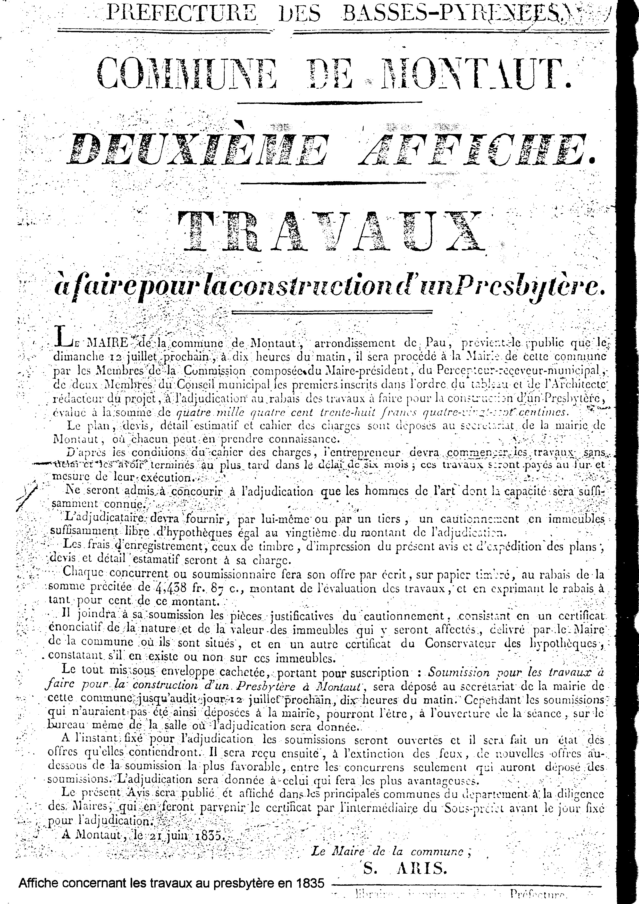
101
The common house
During several centuries the jurats, deputys and notables had met in a small building built between two buttresses of the church and which one named “judicial court”
This name came to it from what it was used as police court in which the jurats, covered with their red hoods, returned justice.
During and after the Revolution, the town council held its meetings there. Its state was a concern and the official reports often show concerns of the mayors, thus in 1809: that its current state is hardly sufficient for the behaviour of the assemblies of the council; that it will be still much less if, following the new Criminal Investigation Department, it must be used as prison… especially, he is not very sure for the conservation of the titles and papers of the commune ²⁵ .
In 1833, the situation becomes more complicated:
the housing where the council was obliged to hold its meetings and the public school also in the same tiny room was very inconvenient for one and for the other… its position being unhealthy and its distress which prevents the town council can sitting there with more inconvenient embarrassment… still to contain the pupils who practise the instruction there ²⁶ .
For this reason, appearing in the budget of 1833, an exceptional expenditure of 1800 francs for the acquisition of the Lagrave buildings in order to build the common house.
On February 7 one proceeds to the reception of the biddings, which will be done with the reduction of the estimate carried to the estimate and the adjudication will be given to the extinction of fires, according to the forms prescribed by the law.
A few days before one had written the schedule of conditions in the following way:
- No offer of less than 10 francs lower than the estimate was to be made;
- All bidders were to carry a certificate of competence for an adjudication and to have a sufficient security;
- The contractor was to conform to any recognized change necessary in the course of execution, except granting a compensation to him if it took place;
- The works badly carried out because of unsuitable materials would be destroyed and rebuilt with the expenses of the contractor;
- The contractor would progressively receive installments with the progress of the work;
- The casing was to be provided by the commune ²⁷.

Posters were affixed February the 17 and 21 and on March 23 were accepted the submissions. It is Jean-Pierre Castet who was selected. He was a carpenter-mason like Alexis Castet, his brother, with the guarantee of Carrouché.
It does not seem that work was immediately undertaken since in February 1835, in consequence of a change of opinion, one plans to build on the acquired land of Lagrange, either the common house, but the presbytery…
Chronique de Montaut
102
Indeed, the preceding presbytery house which did not belong to the commune had been sold as national good and since, the municipality was to rent a house to place the priest ²⁸.
One thus decides, to provide to the expenditure to join together funds: the royalty of the limestones, the sale of wood cuts, that of ferns, the affouage for 3.660 francs. The expenditure will be finally higher since it will reach 4.500 frank, paid by accomptes with the contractor.
Remained always the common house to build… There will still be necessary to wait 9 years!
Indeed, in February 1842 the town council decides to build a vast common house in a site on the basis of Capdebayle front and skirting the brook which passes on this part of the communal place. It will have triple function: a room for the town hall, a room for the town council, the elementary school and a housing for the teacher ³⁰.
On August 8, 1842 one bought the Capdebayle locale for the sum of 3000 francs. In order to face this expenditure the commune sold a revenue of the State, some wood and communal ground, small holdings.
A project was requested from an architect and a selected contractor to which one poured several accomptes. The final acceptance of work was made on September 21, 1849. Besides some interior installations our common house has been such from this time and the school was used to instruct generations as montaltois (29)!

The bureau of welfare
The assistance for the least favoured continues at the XIX century via the welfare bureau. We have in hand the register of its deliberations between 1807 and 1849.
Installed on June 5, 1807 by prefectoral decree, it includes: Maupas, Baylou, Carlon, Julien 2nd born, and Pommés servant of the parish as well as the mayor, Jean Laborde. It names a treasurer in the person of Jean Casenave-Captain.
Its first aid is to make an inventory of the resources. They, as at the previous century, were consisted revenues or obligations subscribed by various inhabitants of the commune.
The sums, in capital, go from 399 frs to 30 francs and its produces interest at the rate of 5%. Where necessary, the treasurer can ask such or such to pour the totality of the capital for which he engaged.
If one believes the text of the summation of it below, some debtors were, at the beginning of 1807, late on their payments; it was thus conceived:
The treasurer of the poor of Montaut with
You must to for the revenues to the poor which had until and including 1806, for expenses of acts bond and insertion of yceux at the office of the mortgages the sum of…………that I invite you to pay in my hands in eighths if you want to avoid the expenses of vigorous continuation. I greet you.
Chronique de Montaut
103
Each engagement of revenue or obligation was made the object of a notarial act which engaged not only the signatory, but also his descendants.
The passage of the duke and the duchess of Orleans
In September 1839, the mayor of the commune speaks at the time of a meeting of the council: the arrival in this department, he says, of LL.AA.RR. Monseigneur the duke and Madam the duchess of Orleans made raise all the citizens to enjoy their presence and to offer the homage of their wishes to them; each city, each common drew up its triumphal arch and the National Guards joined to the authorities of each village went near this monument to make show their zeal and their attachment for their princes. Our commune was to be of the number of those which could be pleased to have seen on their territory that which must, one day, to follow the example of the good king.
Also, I hastened, after you to have made known of it to make raise a triumphal arch at the entry of our commune of which we are, you know it, returned accompanied by national guards to express with LL.AA.RR how much our joy is large of seeing on our territory the heir apparent to the crown accompanied by the worthy mother of the Count of Paris ³¹.
This reception caused an expenditure of 146,92 francs either to make set up a triumphal arch, or for the National Guard, or for the music and having to be supported by the commune, Monsieur the Mayor proposed to open a credit of similar sum to discharge this legitimate debt.

The revolution of 1848
The History continues its course… Our country goes, again one time to change mode and to give birth to in the pain and the disorders a first and transitory Republic. Louis-Philippe is driven from the throne and France, unanimous, adheres to the new mode.
Montaut is not at rest about it and the council, so that no one is not unaware of any, gives an opinion by the voice of its first magistrate on March 19, 1848:
The mayor of the commune of Montaut, after having penetrated himself well of the current circumstances of the regenerated France, considering that the means cleanest to consolidate the Republic which has just put the joy in all the hearts of all the French citizens is to make the choice of the representatives of the people with a scrupulous attention… believes, in the interest of the new government, duty to constitute in the commune of Montaut, a republican communal committee… thus convenes the city council men…
The Bureau made these rulings:
The mortal war with tyrants and the royalty déchue!
Honor to the brave men of February, authors of the Republic!
Help and protection to the worthy representatives of France!
Long Live the Republic!
Chronique de Montaut
104
One vote³² on April 30, 1848 for the constitution of a National Guard. The list of voters contains 332 names. Here the result of the poll (134 voters):
- Navarre Thomas, Saturnin 1st captain 126 votes
- Matardonne Adolphe 2nd captain 72 votes
- Matardonne Casimir 1st lieutenant 78 votes
on the whole 32 men (second lieutenant, quartermaster-sergeant, sergeant, capo- spoke, soldiers)
October 18, 1853. An extraordinary meeting of the council.
The subject was debated, at the same time by the importance of the which decision to take (it will engage the commune in the most important investment of the XIX century) and by the concern for our municipal officials to satisfy the aspirations of their fellow-citizens, (let us not forget at that time the “religious practice” contrary to the current situation, factored in part of everyday life ³³) required all the attention of the council.
The first sentence of the official report is completely explicit: It goes with an inhabitant in the village which impatiently does not await the achievement of a project qu (is not carried out there, for lack of finances.
It is about the foundation of a bell-tower in the commune and the mayor adds: what we have more useful indeed than this construction if we examine the disadvantages of that which we have, if however we can say that we have one ³⁴.
It was indeed about a wall-belfry with bells in the free air, as there are still some in our area and ours was in sorry state: this wall, which one moment to the other threatens to collapse could throw mourning and desolation in one or more families should it unfortunately suddenly fallen… and that while falling, it crushed one or more victims!
Supplementing this apocalyptic description, the mayor adds : But it is not the only nuisance which one has to suffer from the current situation of the bell-tower. Placed in the middle of the wall of the church in a place far from high and by no means turned towards the village, the bells give sounds heard by a very small number of inhabitants. From there the difficulty where the majority are (especially those of the hamlets) to go to divine offices on Sunday and the ordered festivals; from there the displeasure which they feel not to intend to sound the clock almost no hour of the day ³⁵.
The question joining the advisers about the enlarging of the church, the mayor answers: if the foundation of a bell-tower is essential, the enlarging is not.
The estimate is assembled to 16.000 francs. To face this expenditure, it is proposed:
- to alienate a revenue on the State of 183,20 frs, the capital being more than 4000 frs.
- to sell the trees of mature standing timber on the communal properties, sale which can produce 6000 frs.
- to sell various communal pieces for 800 frs.
- to authorize an extraordinary cut of the Content with approximately 1200 frs.
- to sell a few communal hectares.
The council unanimously, gives its agreement.
Chronique de Montaut
