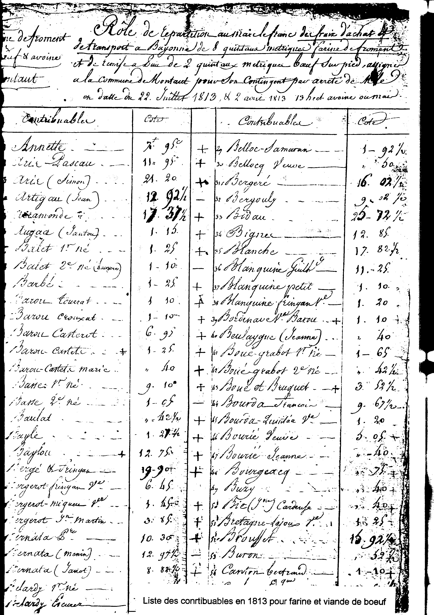
89

The inventory of the liturgical objects
Claimed by the prefect of the Basse Pyrenees8, it proves to us, if it were necessary, that the whole of the liturgical objects crossed the Revolution without damage and are always in service under the responsibility of the sieur Pommez, serving priest:
1 °) one silver plated chalice and its accessories
2°) one ciborium, silver plated
3°) one brass censer
4°) one tin monstrance
5°) one pair of tin oil-cans
6°) one tin dish
7°) one gilded silver bell
8°) one cross out of gilded wood, another of metal for the processions 9°) one banner carrying on a side the image of the Virgin of the Rosary 10°) six ornaments and their accessories of wool 1 white, 1 red, 1 green, 1 black, 2 purple.
11°) four silk ornaments and their accessories. 12°) two paddles, of which one given by Cazanabat and the other bought. 13°) one pluvial, one pavillon of silk damask 14°) another pluvial out of black silk damask.15°) one confessional
All which objects, with the capacity of serving the citizen Pommez are in good condition.
In witness whereof this double inventory was written this day 1st ventôse year XII of the Republic, by us, mayor of the commune of Montaut in accordance with the letter of the citizen Préfet, double for the mayor. Laborde.
Requisitions of Montaut during the campaign of Spain.
All the times of History the communes were solicited in order to contribute their share to the defense of the country in the event of conflict.
Freely agreed or issued authority by a form of requisition, often constraining, this contribution varied in importance during time but it was felt by the rural population as an additional tax whose amount more took into account the needs for its employees with their supplies than possibilities of the agricultural world.
• In certain cases, the farmers of a village which cannot provide the requisitions requested, the Mayor was to buy the supplies outside, to give in a course of time, and distributed the amount for these purchases between the inhabitants of the commune.
The classification of the municipal files made us discover a file “Requisitions military¹⁰ and in particular those of the years 1813 and 1814 correspondent to the countryside of the Marshal Soult.
Chronique de Montaut
90
The reasons for the campaign of Spain
Before entering the analysis of this document, we stop one moment on the situation of the army of Spain at the time of its arrival.
A few years before Napoleon, after having driven from the throne of Spain Charles IV, installed his brother Joseph under difficult conditions. A disputed monarch, this one will have to face, a short time after his advent, a violent uprising of the inhabitants of Madrid (el dos de mayo) repressed in blood by the French troops.
It follows from there the training of insurrectionary juntas which cause many difficulties to the army (defeats of Bailen and Sintranpuis, of Vitoria).
At this time, the Anglo-Spanish armies are commanded by a valorous soldier in the person of Wellington.
The Emperor felt, the need for a reorganization and a resumption in hands of his army of Spain, recalls from Germany where was, the marshal Soult, duke of Dalmatie, and named him on July 1, 1813 with the head of this one.
It was not an unknown for those which he was going to find, he had already fought them as had been illustrated by the catch of Burgos in 1808, the victory of Corogne in 1809, the conquest of Andalusia and the capture of Badajoz.
But the situation had developed much for this time. The successive defeats had de-moralized the army and the difficult agreement of Joseph Bonaparte, king of Spain with his Generals did not improve the reports on the ground.
The flattering reputation of the marshal, often served by a badly organized and badly provided intendance, will only enable him to delay the victorious advance of Wellington who, in our area, will end in the battle of Orthez on February 27, 1814. (to which a monument testifies so, located at the exit of this city in the direction of Dax).

The supply of the army of Spain
Between these two dates (July 1, 1813 to March 1, 1814) a very important share of the supply of the army will rest on our department located, by its geographical position, the nearest. Which was sound importance? The commander Clerc published in 1894 at the military library Baudouin in Paris, a work entitled: Campaign of the Marshal Soult in the Western Pyrenees 1813-1814
Describing very in detail the various phases of the campaign since the catch of command of the Duke of Dalmatie until the battle of Orthez, it draws a picture of the various corps which made the army of Spain.
It bordered 100.000 men who divided themselves into infantry, cavalry and artillery, which meant, among other things, for the bodies of artillery and cavalry significant number of horses and mules for which it was necessary to provide their daily ration of fodder and oats, supply in general reserved for the train of the crews and the intendance, for the men who were to set up the reserves necessary but to also ensure the daily supplies.
Chronique de Montaut
91

The military stores
For this purpose, several military stores (especially intended for fodder) had been set up and their contribution to the supply was a function of displacements of the army.
Nearest to us was that of Nay, then came Pau, Oloron, Peyrehorade, Sauveterre de Béarn and especially Bayonne, whose strategic importance was due to the presence of an arsenal.
To provide for the various and many needs for the army, all the villages of the department were solicited. The requisitions were not limited to the furnishing of supply; we will see, through the documents that we analyzed, that the men, as, were solicited to come to assist in the defense of their country, were the herdsmen requisitioned with their tanks to ensure the transport on long distances of the arms manufacturers whose competences enabled them to bring an invaluable help to the arsenal of Bayonne to repair or maintain the weapons.

Requisitions of hay, straw and grains
According to the documents found in the files of Montaut, that they are of our village or that we them consulted in Pau, it seems well that the period of requisition is between July 1813 and February 1814.
Montaut “was especially solicited” for the supply of hay (533 quintals metric) of straw (381 quintals) of oats (165 quintals) of wheat (30 quintals) and various money sums.
Which was the process employed? The mayor, at the time Aris, received from the Prefect of the department an order of requisition specifying the object and insisting at the same time on the urgency of the delivery (which was almost always to be carried out in the course of the day) and the quality of the supply. Being straw, it was always of the straw of elite, the wheat was to always be of good quality an annotation related to the good the requisition envisages if the wheat is not clean and beautiful, it will be rejected and the constrained private individuals to provide mettable. Measurements of grains were to always be combles and it was necessary to envisage a fifth or more for waste on the road.
Or the commune could face the demand, taking into account its resources (for the straw, the wheat, the oats the hay, as was the case), in the contrary case it was released in money.
The payments of Silver
The secretary of town hall established a “role” to distribute the sums to be paid to the inhabitants.
The imposition of the “taxpayers” varied according to the resources of each one. Thus, for a sum of 550 frank assigned to the commune of Montaut for its contingent of offering to the Emperor by the communes of the canton of Claracq of three mounted cavaliers, armed and equipped, the twenty four easiest inhabitants in other words, richest (Arramonde, Artigau, Baylou, Bernata-Serré, Bernata Pierre, Berger-Fringan, Berger Alexis, Vve Bidau, Blanche, Brousset, Cazalaa,
Chronique de Montaut
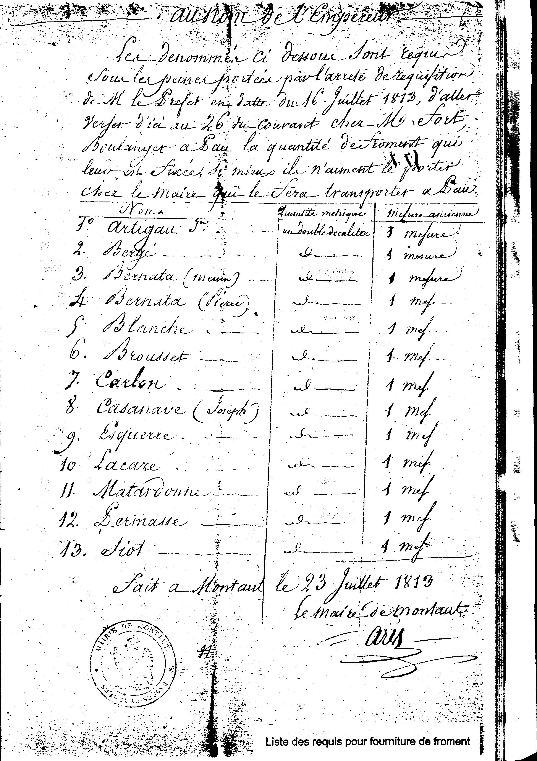
92
Matardonne fils, Daguette, Esquerre Simon, Hourquet, Lavie, Loustau, Matardonne Père, Mongoy, Sauque, Siot,) charged with this contribution, on August 19, 1813.

The Horses and the mares
The requisitions related also to horses and mares for which regroupings were envisaged in certain communes for an inspection.
Thus on February 29, 1813 such a gathering is envisaged in Asson, whose mayor Marcadet is named, for the circumstance, commisaire for the examination of equine.
In his convocation the Prefect showed his concern for preserving the race; he wrote: “I recommended that the choice relates mainly to the horses and the mares found sterile in order to spare as much as possible the brood mares”.
In order to dissuade the possible recalcitrants, the prefectoral missive specified: “I warn you that if some owner sought to withdraw his horses from the knowledge of the administration and that they were then discovered, the price would not be fixed privately they would be only according to tariff of the minister.” Was this threat effective? We do not know; only that 44 proprietors of Montaut were present at Asson with one or more horses.
The beds and the covers
In August 1813 the mayor Aris is solicited to provide elements of bed linen for the army “in good condition if not they will be rejected” (covers, straw mattresses, traversins, mattress).
Giving himself the example for a cover, he encourages some of his administors (Baylou, Bidau, Blanche, Brousset, Cazlaa, Cazanave, Joseph, Esquerre, Siot, Permasse, Bergère, Mongoy), to follow his example.

The meat on the hoof
The requisition which seems caused the most difficulty for the mayor of the time was that of the meat on the hoof.
A letter of December 2, 1813 announces his concern to us of the receipt of a request, gone back to the end of November, “to provide without the least delay to the store of Bayonne: 9 quintals, 71 kilogs of meat on foot in the proportion of 3/4 of ox and 1/4 of cow or 1/3 of meat of sheep, 2/3 of ox, namely: the ox 280 kilogs, cow 180 kilogs and sheep, 25 kilogs at least. ”
These precise details plunge our first magistrate to the greatest embarrassment; he writes to the Prefect saying to him: “I do not find in my commune any ox of the weight which you fix, no cow, even less, no sheep. ”
He however does not wish to be concealed, although he considers this requisition “considerable for his commune, although it is destined “for brothers who, in the middle of the rigours of the season pour their blood for our defense and the safety of our people and our goods”.
Chronique de Montaut
93
- it runs to Pau to a certain Mené, undoubtedly a wholesale meat supplier but a price lower than 130 francs per quintal does not manage to obtain. Frightened this excessive price, he acts in concert with other mayors of his canton and, together, they obtain aa additional 10 francs per quintal and give their agreement for the forwarding of the meat to Bayonne.
Informed thereafter, the sub-prefect found the price too high and did not agree to pay some of that part… Angoisse the mayor of Aris in front of 'this decision! He will have to distribute the difference on his managed of which he fears the reactions!
The men
This period took place, not only with various requisitions of food products, but also of men specialized in a determined occupation and whose know-how interested the army.
We thus found several correspondences exchanged between the mayor and the sub-prefect of the district of Bayonne between the 3 and on October 20, 1813 concerning two arms manufacturers of Montaut: Toulou and Navarre, necessary to join the arsenal of Bayonne as soon as possible. The mayor having asked for additional time in order to allow the routing of these two men, receives dated October 12 a comminatory letter of the sub-prefect of the district of Pau (interested parties not yet being on the way) enjoined to him the execution of the above mentioned decision in 24 hours and threatening them (in the event of inexecution) of the garrison.
A few days pass… new letter October 18 giving a report on the disobedience of the two arms manufacturers and issuing the garrison to 2,50 francs per day to each one of them.
The sanctions are effective since this levee is raised on the 20, our two men take the road to Bayonne.
Bertrand Navarre (who really did not want to remain at the arsenal) did not remain there a long time. A dated October 25 certificate signed by the directing colonel Commandant superior of artillery of the place gives a report on a serious and incurable illness contracted by the interested party who is returned to his hearth where he will continue his existence… fifty one years!
Another inhabitant of Montaut, named Larcade Jean, is sent to the arsenal on September 5 to work there with the repair of the weapons, as he is only a blacksmith and not arms manufacturer he is also returned to his hearth.
The transports
In addition to the furnishings of the products intended for the supply of the army, our village, like the other communes of the department, was to also ensure their transport to the military stores.
One thus had recourse to the service of the herdsmen and their tanks for these various convoys. Some of them exceeded the framework of the department and overflowed on Spain, like this requisition order requiring of the harnessed cars “of four mules, horses or oxen to be sent as soon as possible to Bayonne to
Chronique de Montaut

