86
The XIX century
The revolutionary wind passed; on Montaut, stormy in the beginning, breezy at the end of the century, without leaving many indelible traces. The first to join with the new ideas will be also the first to grow rich, satisfied to suspect the new mode the recognition of their acquisitions.
It is of good note at the beginning of the ninteenth century to join with ideas of order. The “petit corporal” will be soon on the throne of France and will involve behind him the mass of the French to the cries of “long live the Emperor! ”
Our village continues on its shiny road, as in previous centuries, of more or less various remarkable facts which we now will tell.
A medical regimine for an inhabitant of Montaut¹
Mr. Laborde, doctor called to the bedside of Padre diagnosed various digestive symptoms (perhaps following too important drinkings!) and writes to him the following ordinance, allowing the concoction of a medication which will allow:
1°) to melt the embarrassments of the internal organs
2°) to decrease the irritation and the pain,
3°) to restore the digestive functions.
One will fill with the first (1°) by resolvent dilayants internally and outside such as: whey in abundance, while making precede the catch by the morning by the following powder:
Eyes of crayfish prepared and red coral; of each: 10 grains, two cataplasms cooked on the belly made up with sheets of marsh mallow, pellitory and reprimand.
One will decrease the irritation of the pain (2°) while outwards carrying the mood watered by the preceding remedies, while frequently using a made up medicine with:
Pulp of Casse, one ounce; salt of Gauber, two large; fine basket, two ounces.
One will restore the functions of the stomach (3°) by the use of the wine of Kinkina taken in the amount of two ounces each morning.
To employ these various means it is necessary to start with a little milk during one week, to purge the eighth day, to return to the whey repurger, in the same way, observing to take of two in two days a rectal injection.
The use of the wine of Kinkina should take place only at the end.
If, during the treatment, the pains of head became violent, it will be necessary to bleed the patient at once.
In a few days, to give news of the patient.
Chronique de Montaut
87
Joined to “the ordinance” a chronological table of catch of the various potions, for approximately one month. The fees of had amounted to 1 livre, 4 sols.
Unfortunately, the history does not say to us if the patient was cured…

The road from Coarraze to Montaut…
The maintenance of the roads always represented a heavy charge for our communes.² On their good state the facility depended on the communications between agglomerations and more particularly that which enabled us to travel to Pau, to ensure, among other things, the traffic of lime.
Several deliberations during year I and the year VIII³ announce concern to us for our municipal officials. Thus that of the 14 fructidor, there that “the road is in a state to more be able to pass; the moved stones of which most of its surface is covered and who expose the most imminent danger to the travellers; cesspools or excavations which become the receptacle of all rain water and which are desiccated only in the strongest heats of the summer.
The mayor adds ‘our single trade,which vivifies the commune is the sale of lime. It is by this trade that this commune and certain preponderance of its neighbors, which is acquired only by the heavy work to which our fellow-citizens deliver themselves. The 9/10 of this lime, I will say almost all, must be transported by the carriers to the places where it must be employed, such as Pau, Morlaas and one can say to almost all the communes which form the district of Pau.
He specifies that the carts break there and that those which are slightly harnessed must give up making their own cartage or must go to traverse more important distances to find a road in better condition.
He decides to address a petition to the Prefect to ask his assistance and to sensitize the inhabitants of the two communes of Coarraze and Montaut, both recipients in the maintenance of the road, Pisson-Abadie, writing with Marrimpouey, mayor of Coarraze⁴.
The 15 pluviôse year IX, the town council meets again to examine its answer. It is decided to draw up a list of all those able to contribute to the repair with oxen and carts, and those which can offer their arms to charge and distribute materials.
The mayor decides to go to the spot to direct work and is pleased, in advance of the success of the operation: We will enjoy approvals which a beautiful road promises, the transport of lime, our principal trade will be easier… but other repairs are to be made!
A few months later, another deliberation informs us of the dramatic state in which the bridge is on the Sacq⁵ (actually, the brook of Séré) built out of wood and of a dangerous narrowness, moreover the casing exposed to the injuries of time each day decays. Located in a hollow (even more important than today), the surface waters come to rot the beams which maintain it after a fashion. It is necessary thus to build a bridge with lime and sand especially that
Chronique de Montaut
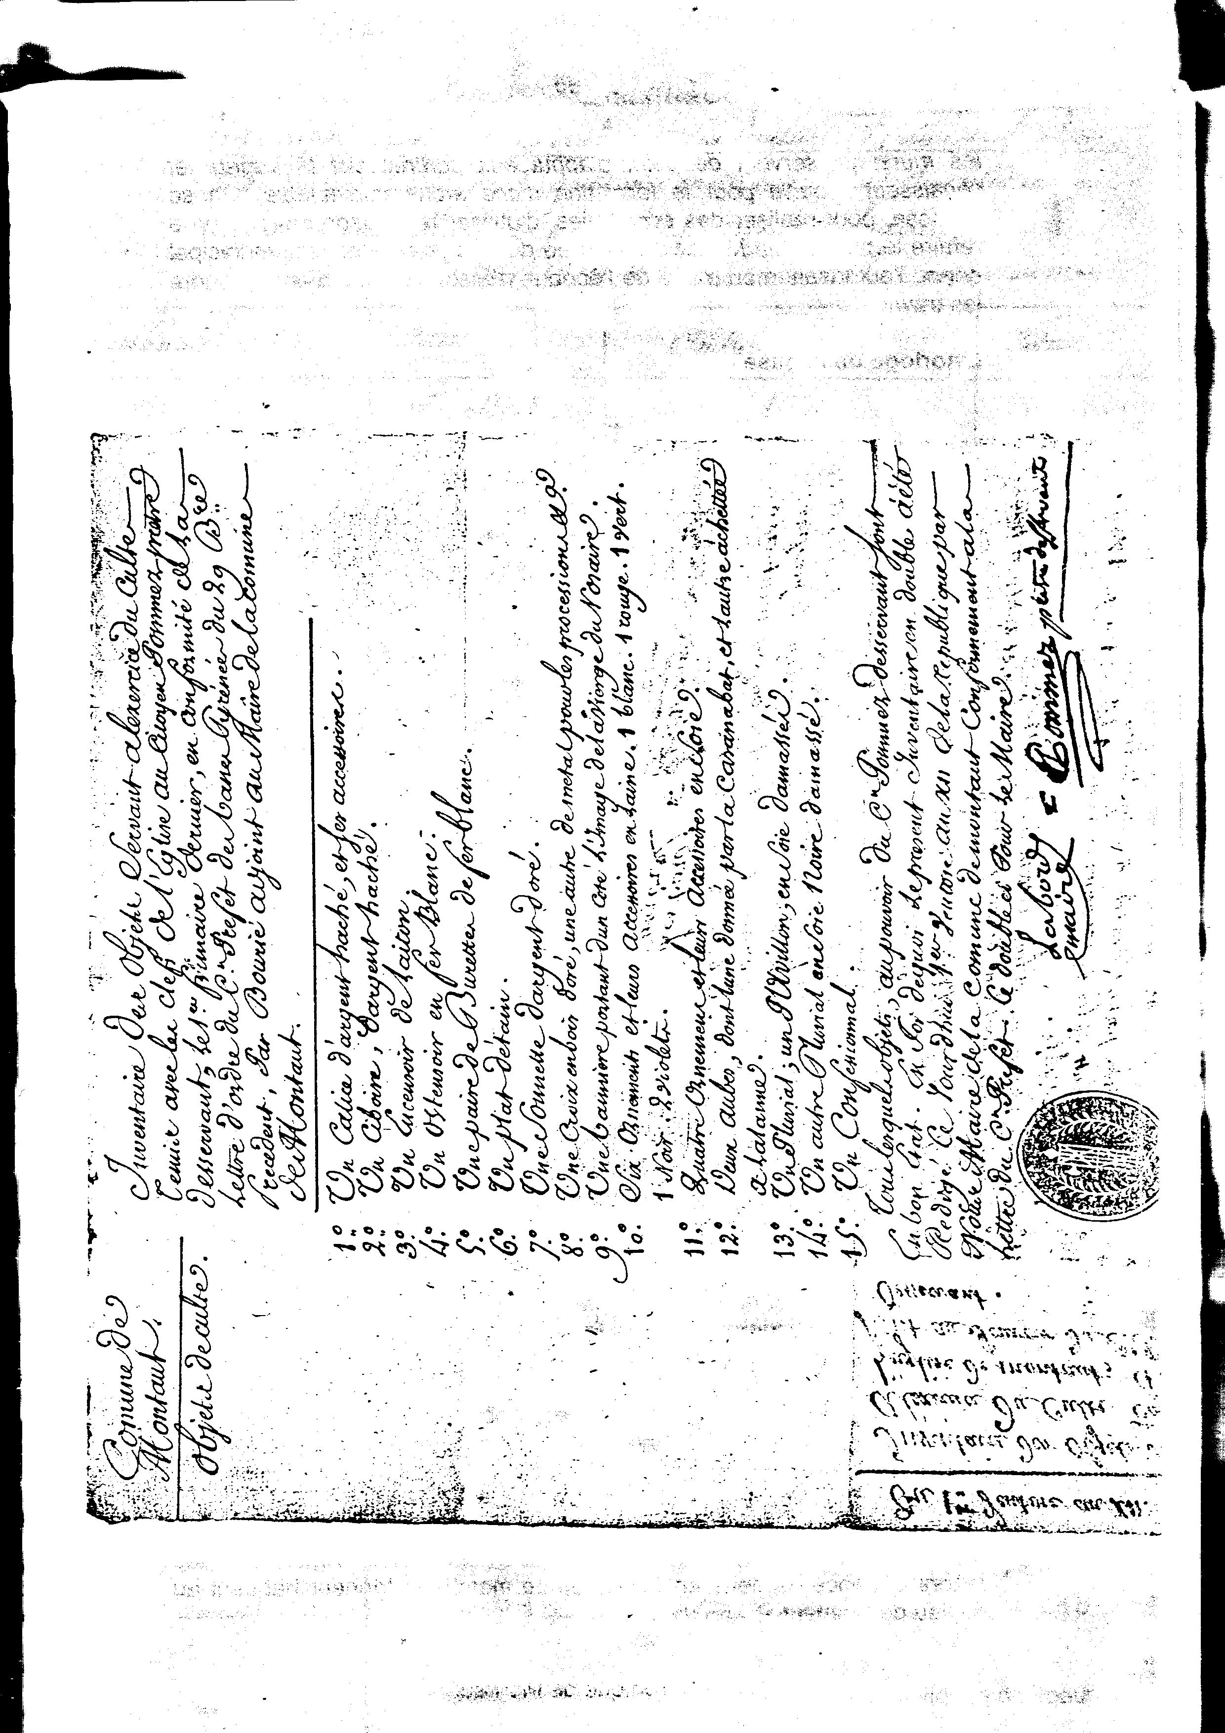
88
the walls which are used as points of support with the beams have not the width and the thickness necessary for the formation of a suitable arch. One proposes, to realize savings, to use the casing which was used to remake the bridge on the Mouscle at the entry of the village and the town council gives the authorization to the mayor of the time, Pisson-Abadie, to undertake work.

The clock of the church
At the time of the sale of the goods of church, on a decision of the French National Assembly of May 13, 1790, Etienne Bourrié, procurer of the commune, purchased, with the agreement of his colleagues, the clock of the chapel of Bétharram. The sale had taken place with the biddings and he had been the strongest bidder.
Once the clock was brought back to Montaut, our municipal officials wondered about the choice of the best site. One decided, using a rather rudimentary frame, to install it against the wall-belfry built at the southern end of the church.
This provisional installation lasted ten years. It is only in 1802 that a meeting of the town council refers to this detrimental situation to a number of inhabitants: It did not have summers possible of (the clock) suitably placing so as to make it generally useful. There is nevertheless more money today than yesterday, but the majority of the inhabitants are tired of the uselessness of such an acquisition. It is necessary to raise the mechanism of the clock which is good and regular as a practitioner of the openings (undoubtedly in the bell-tower) which assist the propagation of the sound rays, which is not the case.
An estimate is requested from a contractor, but it will be necessary nevertheless to wait more than one half-century before construction of a new bell-tower provided a clock.
The tanneries of Montaut?
Leonce Peyrègne had suspected their existence. For our part, and in the current state of our research, we only found in an official report of a town council of the 5 ventôse year XIII. a transcription of a decree of the Government of the 9 frimaire of the same year, concerning the notebooks whose workmen were to be provided with the fabrics.
The publication of this decree had been made with the sound of the drum to the accustomed places and notified by speaking to the commune:
- with the chief of the paper factory, the sieur Bourjeacq, while him, while giving a collated copy;
- with the foreman of tannery, the sieur Casannave-Lalanne.
We could, since, thanks to the kindness of Mr Jean Jerusalem, to locate this tannery which was at the beginning of the current street of the Fields and which used the water of the brook which passes in the vicinity to wash and tan the skins.
In the solicitors records of Julien, royal notary (III E 6603) we found an act dated August 7, 1755 confirming an ackowledgement of debt in favor of this tanner merchant living at the place known as Montaut
Chronique de Montaut

