The health of our fellow-citizens was in the hands of ““doctors and surgeons” Gabriel Julien, was one of them; his human competence and his qualities enabled him to cure and to relieve a number of his fellow-citizens who, perhaps by recognition, élirent jurat.
All legal documents, and they were numerous, passed between the hands of a notary, and Montaut could be enorgueillir to have a royal notary, whose holder of the charge was Pierre Julien. His functions consisted of writing acts of sales or purchases, of the lime supply, marriage contracts, apprentisship etc… He also dispersed his councils to all those which came to find it.
In the role, neither the priest, nor the vicar were forgotten Jacques Pommez and his vicar Trille were two of the strongest voluntary contributors, for several hundreds of livres, to undoubtedly show themselves well as authorities of the time. The handwritten mention affixed by pasteur of Montaut beside the figure of his contribution deserves to be quoted:
And if, when the Nation wants to refund I am no longer alive, I want that it (the contribution) be versed to the Bureau of the poor to come to assist the most unhappy.
Creditable intention, certainly, but doubled of a certain amount of naivety as for the possibility of being refunded by the Nation!
To complete our information, we proceeded using the “Contribution” surveys to allow us, under the reserve which is about a declaratory tax⁸¹ not reflecting obligatorily the totality of the incomes, to make opinions on the state of the incomes procured by some of these professions.
The 72 laborers provided a total contribution of 1.309 livres, i.e. 59% of the total and an average of approximately 18 livres per capita. Their average income was, by far, the most important of the village. The variations are substantial, since the weakest is of 3 livres and highest of 24 livres, a variation of 1 to 8. One bringing together with the owners of lime kilns can be an element of explanation of these variations.
Continuing with the manufacturers of chapelets; they were 32. Their contribution is of very an other level since it reaches only 2 livres, 12 sols per capita, with, as for the laborers, of great differences.
In the same category of incomes then the various manual trades come (tisserands, tailors) whose average incomes are brought close to those of the precedents.
The men and women day laborers are located at the bottom of the scale, he can only give to the State 1 livre, three sols, on average. The variations are nevertheless important between male and female remunerations. (did we progress much since? )

The inventory of the national goods
On May 13, 1790, the French National Assembly votes on a decree regulating the sale of the goods of the clergy to become national goods.
Chronique de Montaut
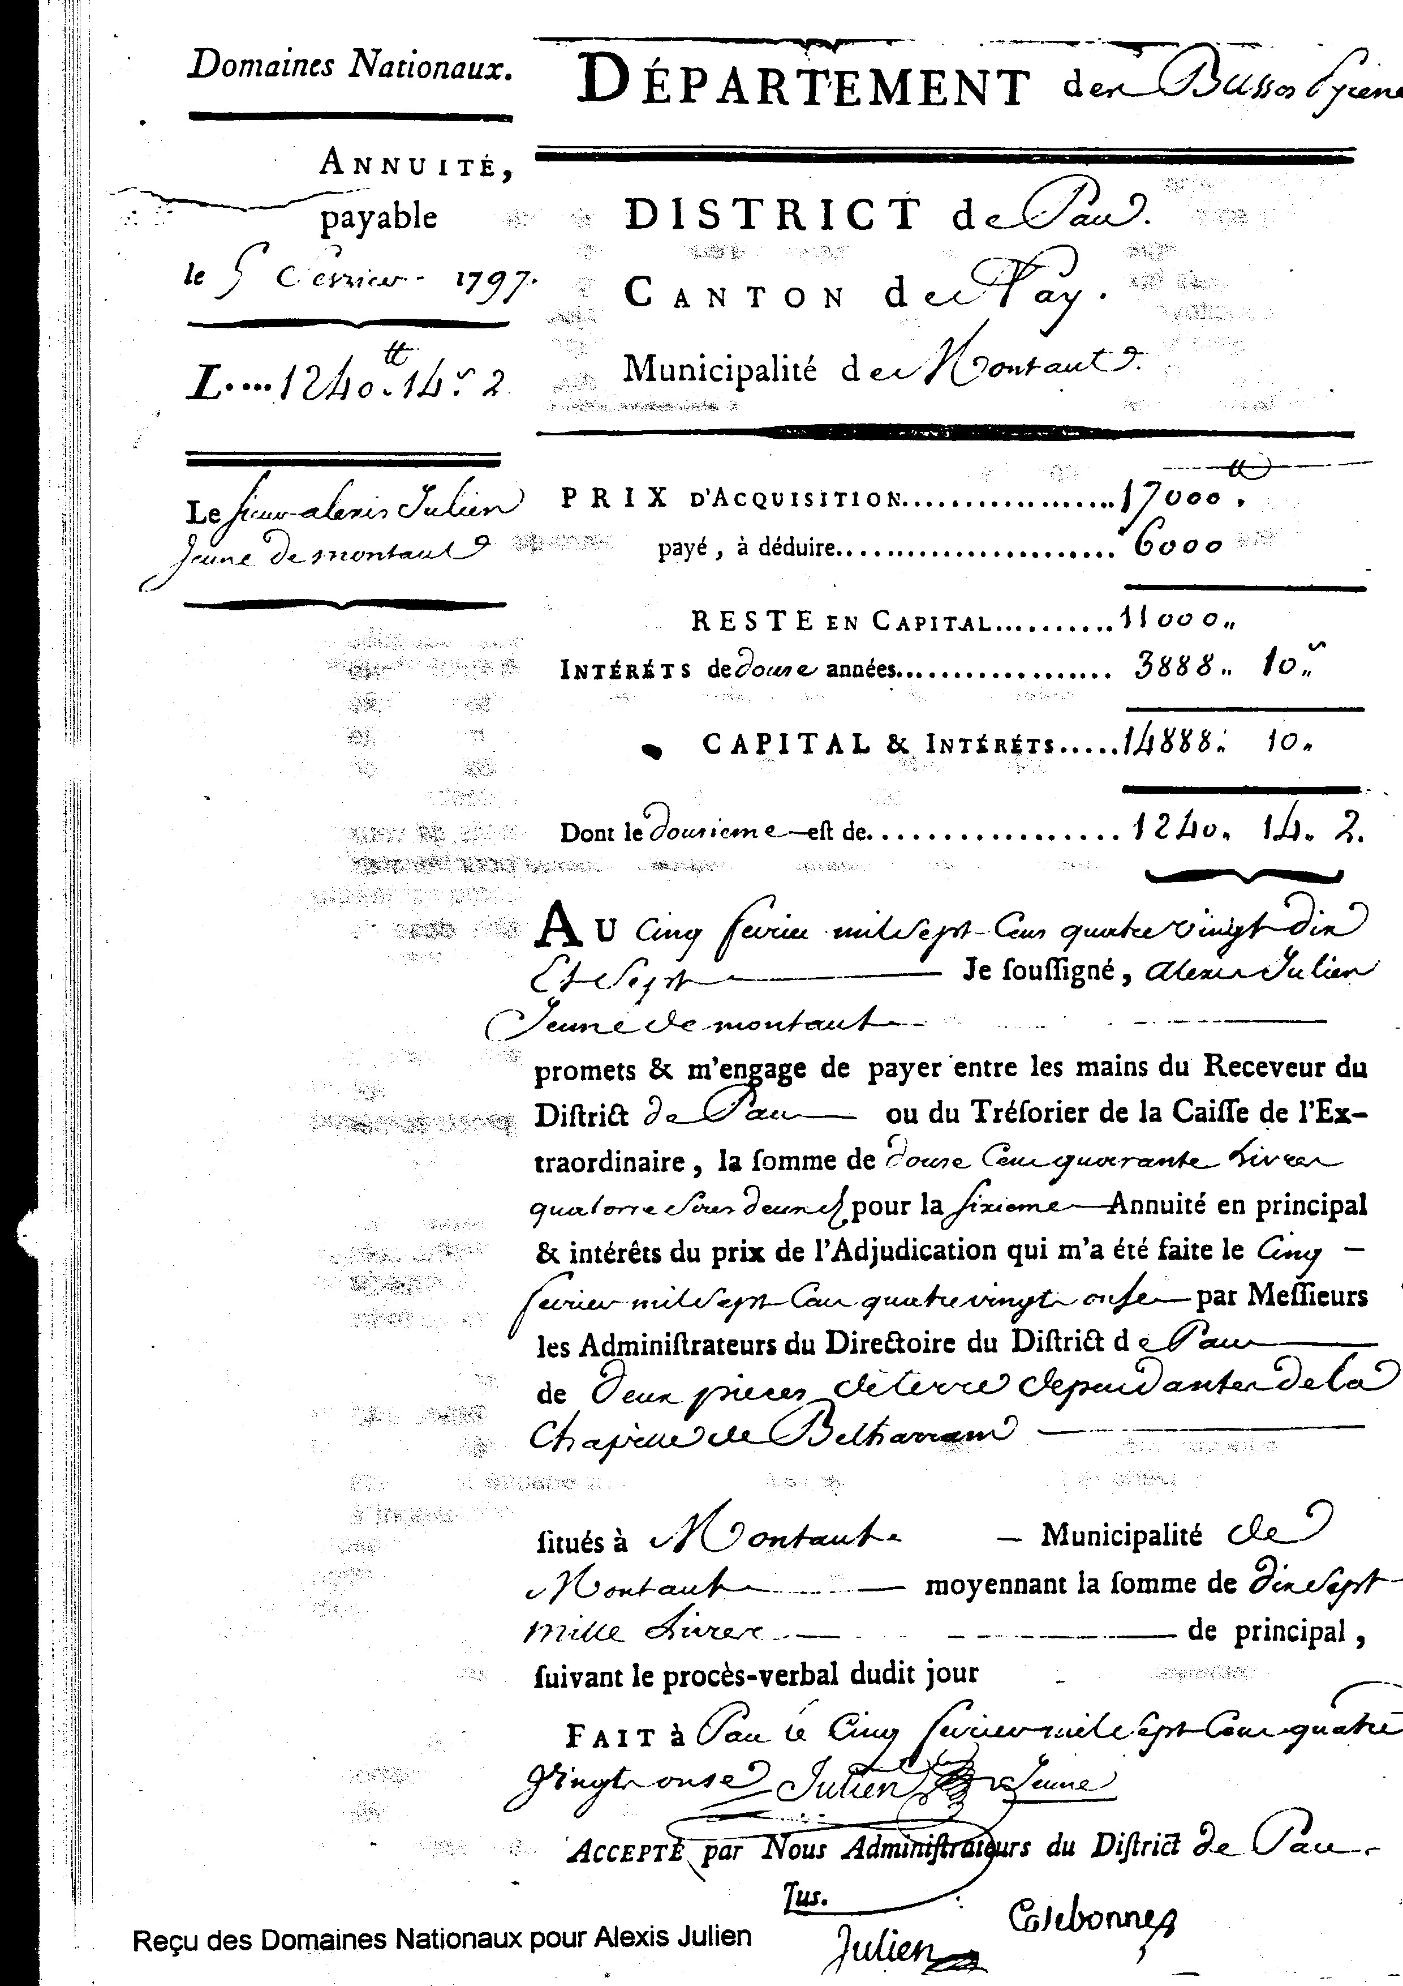
73

In Montaut, the procurer of the commune Etienne Bourrié makes on August 3 deliberations which decides on their inventory.
We see that into the XVII and the XVIII centuries, in consequence of acquisitions and of important investments, the chaplains of Bétahrram had become land and real estate owners. Their goods fell under the blow of the above mentioned decrees.
Here the contents of this enumerative deliberation: 'Those consist of a mill of flour and a simple paper mill, Couteillon with the bow net, meadows of artigues in front of the mill and below, house, barn, farmyard, holding with a patch of land Ségalas and vine Berge, arable, the Barères part, house, so arable garden, the part Artigue Barrade, the part Artigue de Barbé, the part Lagrabe, the part Grabet on top, the part Artigue Douissaa and Lartigot Darvin, Cabiroulé as well as the Trip hammer, the whole forming approximately a hundred and ten arpents of ground, large pole.
A state of the revenues of the house of Bétharram comes to supplement, for the most important goods, this inventory by specifying the income of each one of them:
- a paper mill leased for 600 pounds
- a mill of grains leased for 750 livres of silver and 50 grain sacs, half in wheat and half in millocq and six pair of capons, the whole evaluated with 512 pounds. (total 1.262 livres).
- a Trip hammer and a house in the village, the whole free leased of any charge for 60 livres.
Adjudication of the mill, the paper mill and the Martinet (Trip hammer).
The administrators composing the Directory of the district of Pau, after an expertise carried out by Carlon, of Montaut, decide that the adjudication will take place in the assembly room of the Directory of Pau., on Saturday April 16, 1791 at 10 o'clock in the morning. Publication of the decision will be made in Pau, Nay, Montaut, Lestelle, Igon, Coarraze,
During the first adjudication, Gabriel Bourgeacq de Nay, Montaut inhabitant remain the strongest enchérisseur at the time for the flour mill, the barn and the part of the garden affected, for the sum of 3.325 livres and the paper mill, barn and affected garden for the sum of 4.575 livres. –
A second adjudication takes place on May 7. During this one, the biddings are as follows:
For the mill :
- Duclos junior, man of law,
6.000 livres
10.500
11.800
12.000
12.300
19.000 adjudicated.
- Soulancé of Nay
- Pommé
- Soulancé
- Jean Tucquet of Montaut
- Soulancé
For the paper mill :
- Duclos
6.000 livres
6.500 livres
9.600 livres, adjudicated.

- Pommé
- Soulancé

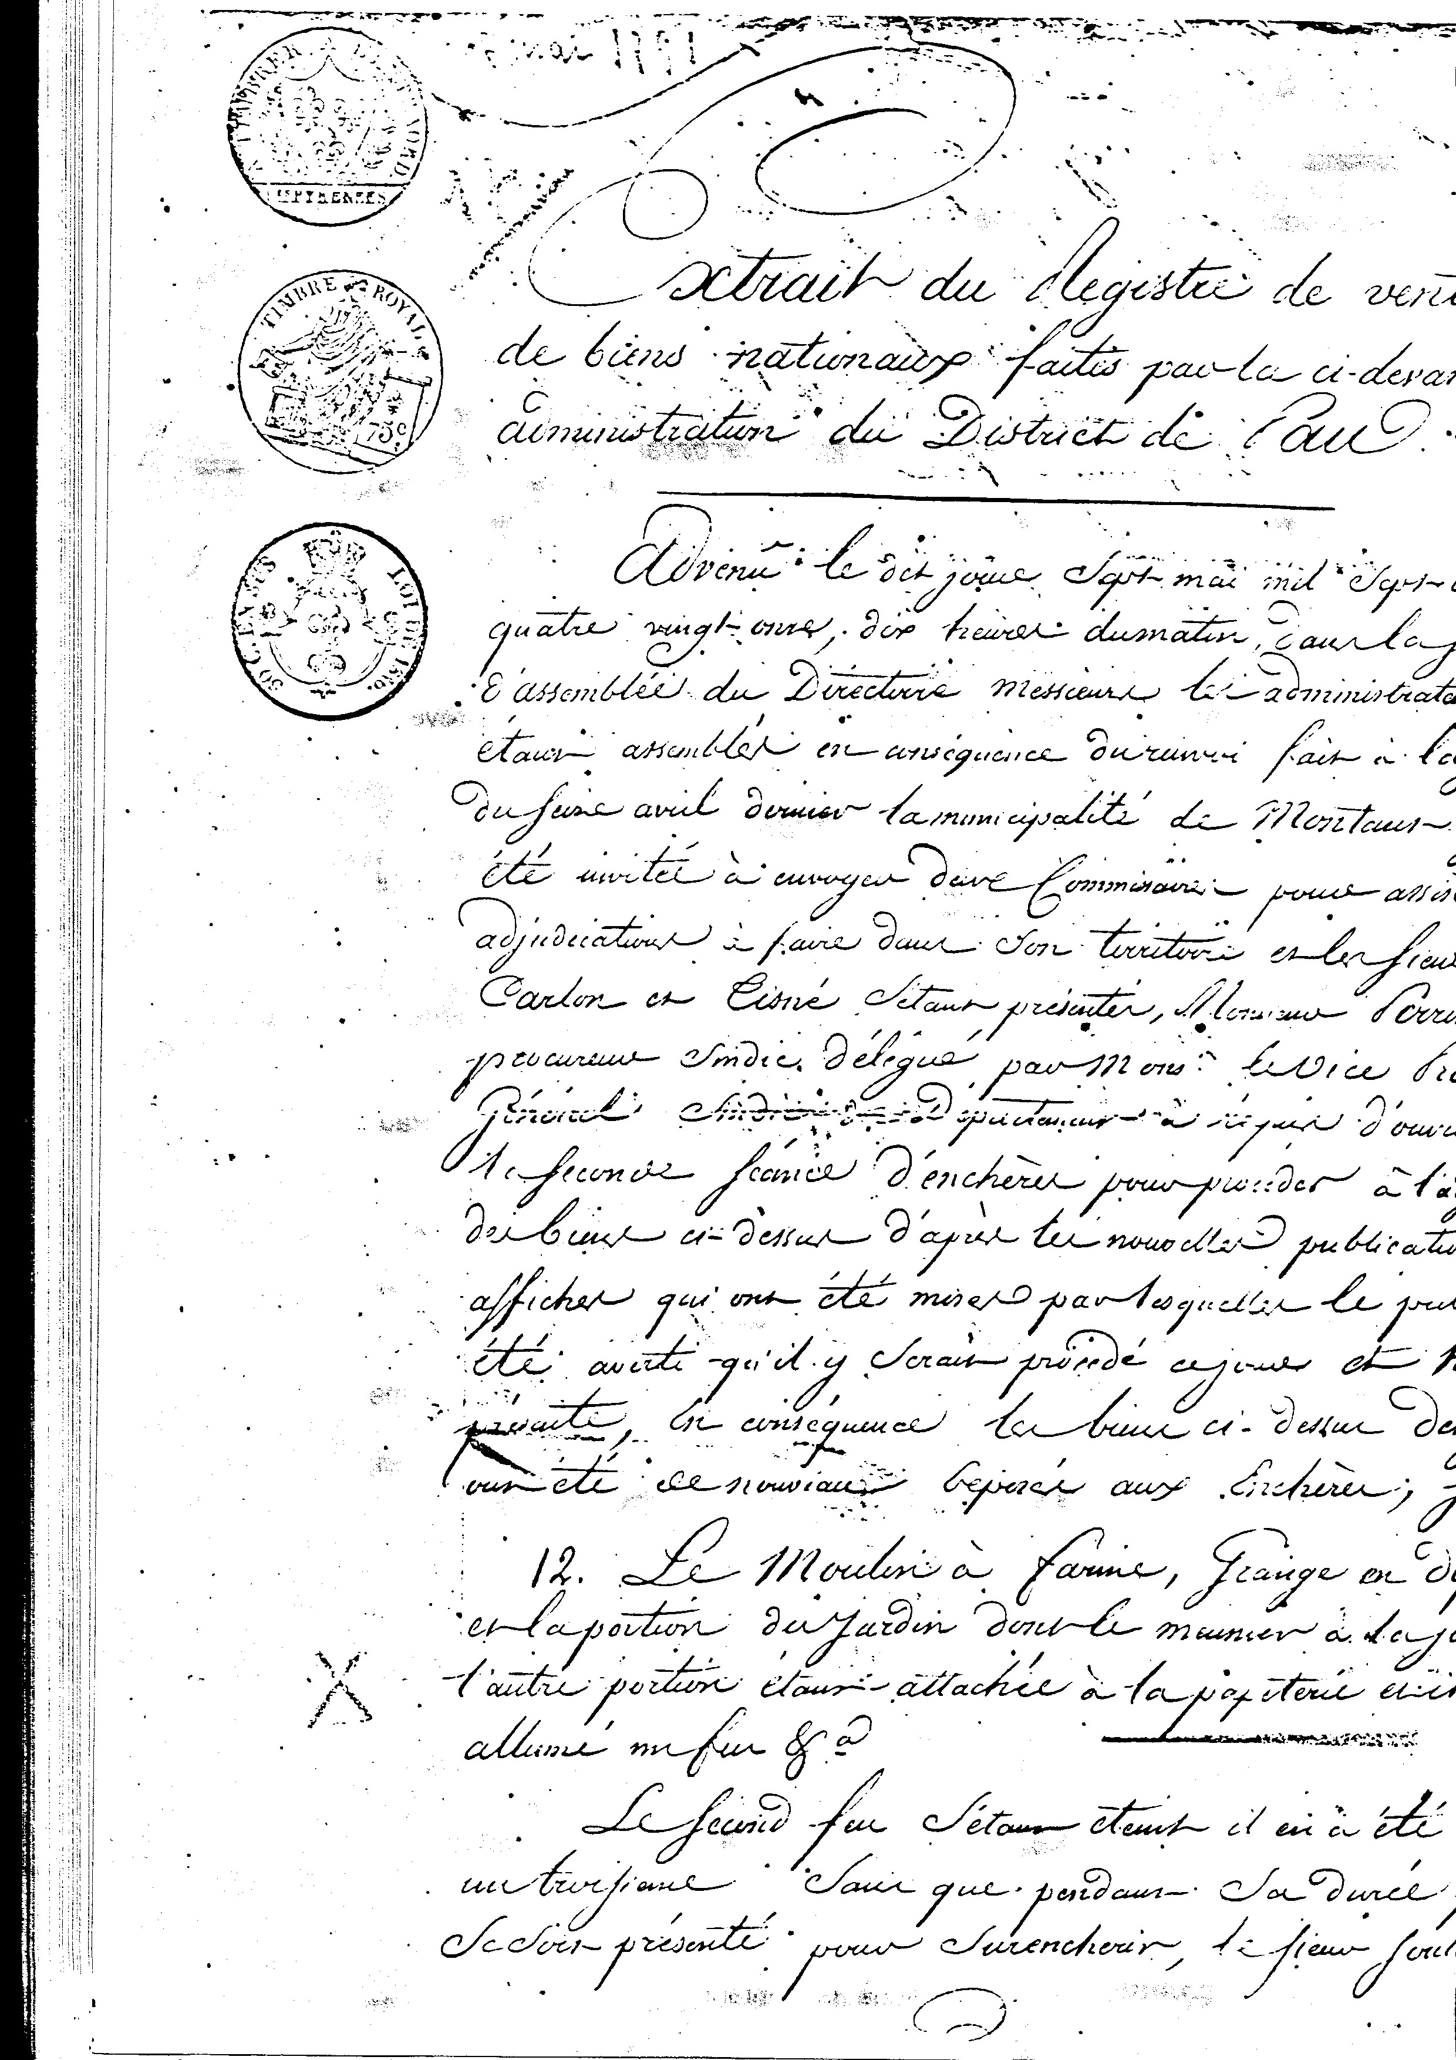
74
Thus for 25.600 livres, the sieur Soulancé⁸⁴ of Nay became the owner of the mill of Couteillon and the paper mill.
The Trip hammer of iron, property of the chaplains of Bétharram, was sold as national good on May 7, 1791. On an estimate of 820 livres, the biddings climbed to 10.800 livres, of some importance at the time. Three purchasers⁸⁵ had to group to join together: Gabriel Cazala, Bernard Cazenave and Jean Cazenave-Capitayne, whose son Jean-Pierre following a judgement decided on February 25, 1853 of his auction sale, in consequence of an impossible division between several joint owners, will become from this the purchaser for the sum of 9050 francs.
According to the old ones of Montaut, the Palisses mill included three sets of grinding stones, to which a small paddle wheel was added involving one to grind flour.
Some of them, schoolboys well before the last war, remember bringing to the mill on the luggage stand of their bicycle a bag of grain while going to the school. This same bag was taken back in the evening while returning to their premises. Its capacity, because of its weight, did not account for more than one to two measurements.
The miller made the round of his customers with a cart with an ass, taking the grain and reporting the flour.
It also happened that farmers came with a tank to grind greater quantities of corn. All this activity concentrated around the mill made it a place of meetings, conversations and an exchange of news.
The crushed corn made it possible to obtain the “breuille”, the basis of daily Talimentation, obtained by cooking corn with milk or bouillon. At the time of the “pig slaughter” with the blood of the pig, one made the “miques”.

The purchase of Salliet
Another acquisition particularly interested the administrators of our commune, it was the wood called “Couteillon” and its contiguous grounds, of which Sailiet, name besides, which to him always remained.
Etienne Bourrié, procurer, submitted a report to the council summarizing the advantages of its possession for the commune “one draws from it the mud to improve the grounds and stones and of sand (it was about an old bed of the Gave) to build houses and barns, one uses it for the pasturage of all species of cattle and it provides glandée (right to graze pigs).⁸⁶
The chapel of Bétharram had the right to cut there oaks for the maintenance of the bow net of the mill and replanted young trees there.
The procurer thinks to buy with joint funds and little wood “lou Sailiet” to enjoy it like the commune had always enjoyed, because without it they were without the resource for the maintenance of the cattle.
After deliberation, it was decided to follow the opinion of Bourrié and to acquire the aforesaid part, the sieurs commissaires and the procurer will be charged to make the representation in front of the administrators of the Directory of the district of Pau. Signed: Prim and Tisné, minicipal officers, Navarre, Carlon, Laguerre, Lanot, Casalaa, Matardonne, Bayou, Laborde, notables Hourquet, secretary-clerk.

Chronique de Montaut
75
Again, a deliberation of June 1, 1791 comes to supplement the preceding one and names commissaires to stipulate⁸⁷ of Julien, the younger, the transfer of Saillet wood, that this last had acquired with the intention to reassign it with the commune. He had paid it 3225 livres and carries out this retrocession in the study of his father Pierre.
Alas, in 1875, a flood of Gave, will carry part of wood. The scars still present today by the variation of level between the two grounds,
Who suspected that two centuries later, after its acquisition, the destination of this place would change and that it would be used as formation and competition ground to the amateurs of the round balloon! …

The festival of the Federation of Pau
On June 27, 1790, the town council joined together and decides to send a montaltoise delegation⁸⁸ to Pau on this occasion.
One appoints the mayor, François Aris accompanied by 29 soldiers, under the control of Thomas Navarre, captain.
So that they all can hold their row and honor their commune, the council votes them an important budget, (the parting drinks were undoubtedly numerous) so important besides that, a few weeks later the commune does not have any more money to pay the last pacq due to the contracting company of the work of the fountain of Bruquet. The treasure is empty… and it is necessary to borrow, as specifies in the official report of July 30, 1790: the siuer Bourrié, procurer of the commune said that having been obliged to make expenditure for the Federation the 27 of last month and the 14 of the current for the voluntary soldiers of the National Guard to give them some small collation and the purchase of flags and drums, realising this, the small revenue which the community was to have in the purse of the treasurer is exhausted and not knowing, for the present, where to take to pay the last pacq company and adjudication of the fountain to the contractor…

The distractions of the village
In 1774, the inhabitants having made the company dispatch a tragedy, the first day the weather was bad, having dresses up their crown, they remained eight days without being able to go. They had many expenses on this subject. They were presented in front of the inhabitants one day of assembly. The inhabitants granted them 12 livres.
In 1758, one had paid 12 livres “to the youth* for the pleasure which they had given by representing the tragedy of Athalie.,” and 9 livres in 1764 for the representation of Zaire
At the time of Christmas Eve of 1755, Holy PolyQi and Canton had played the flute and the violin during the one and midnight mass had offered to them drink for an amount of two sold.
At the previous century, in 1626 and 1627 a collation had been been used for the players of violin and tambourine for the Saint Hilary, and in 1658, for those of the masquerade.

Chronique de Montaut
76
How to be made pay his due…
One of the inhabitants of Montaut lends a certain sum to the one of his neighbors, with promise of restitution. At some time from there, the creditor worries about seeing anything coming…, he thus solicits his debtor, who answers him that he has neither gold nor money!
That's no problem, it will be paid in kind… and he seizes by the usher: a copper cauldron, a frying pan, a brass poêlon, a jug with three iron circles, a pair of fire-dogs used for fire, two beds furnished with the mode of For de Béarn, a shoed and closed trunk with key, 12 ewes, a measurement of oats, six quartaux of plane wheat and a pig with hairs.

The sale of the wine - town due - the policeing of the cabarets
The selling price of the wine in the cabarets of Montaut seems to have attracted, at that time, the attention of the members of the council, more especially as the innkeepers did not pay a tax…
On January 17, 1784, day⁹² of general assembly, one of them made in the common house (actually, the court) the explaination for higher tariffs than in the close “parishes”. The jurats, taste, enquièrent purchase price of transport and other rights or taxes and decide to fix the prices:
- Jeangran: old red wine 9 sols per pot, the white 7 sols per pint.
- Navarre Pilou: old red wine, 10 sols per pot and the new pot, 6 sols. It is the same for Jouandou and Hurou Pedebeye. Moreover, defense is made to the innkeepers to sell them at higher price and sell some which is not taxed by two jurats in the common house. In case of infraction, fined 10 livres!
As we will see, our innkeepers were not at the end of their sorrows…
The entry of the wines in the commune gave the perception of a town due on the wines sold with the detail of profit to the municipal budget. This revenue “was leased” and sold to biddings for three years. On February 18, 1857 it had fallen to Jean Artigau after various higher bids in the presence of M.Dagest, subdelegate of the Intendant of Pau.
His setting price had been 700 livres, M.Lassalette, procurer with the Seneshal had raised 170, Labéron, expert, 800, Jean Pasquine, ploughman, 900, Jean Artigau, 950, Jean Tisné, dit Malescrabes, 970 livres and Jean Artigau had been adjudicated the sum of 1000 livres”, with the guarantee of Jean Navarre dit Pilou, hotelier.
Knowing how this right was for 4 livres per barrel, the annual amount of the royalty, without the “farmer” earning any money was 3.333 livres, the number of barrels drunk was of more than one per week!
At the beginning of the year 1791 our municipal officials, sensitized by the complaints of various inhabitants of our village, enacted some payments and made visits to various cabarets in order to realize the effect of their decisions.
Chronique de Montaut
77
Thus the mayor François Aris, accompanied by Jean Prim, municipal officer, consolidated with Simon Araxi, Jean Pierre Cazenave, dit Araxi, father-in-law and son-in-law, we are transported around the eight hours and half or approximately to the cabarets of this place where we made the visit; we found at Fermasse dit Garrot a quantity of people who hid, benefitting from the obscurity and darkness of the night, as also of the finesse of some who closed the door to us to have time to hide and to ferment their wine. And as undue hours to exert justice we returned to it tomorrow February 3 present month to challenge the aforementioned Fermasse and Jean Barou, junior to punish them for their infringment. To the meeting of the following day, Fermasse says he bailed out with a 3 livre fine!
On February 12 of the same year, François Aris, Jean Prim, Thomas Navarre, Jean Lanot and Bertrand Canton make a political ordinance concerning the innkeepers; here are the terms: We Mayor, municipal officers being assembled at the judicial court in general council of the commune of Montaut, being informed of the insults and considering the contempt which the innkeepers and the inhabitants make as well the royal decrees and the stops of payment of May 15, 1790 made notorious with all the ordinary inhabitants as those our predecessors and last payment of July 9, 1782 which defends the innkeepers to hold of the world during the divine offices, the days of Sunday and festivals neither since the Angels sounded the other days and these and renewing our defenses herein contained, defend with all the innkeepers of this place to not give wine drink, eat nor to play in their houses nor dependences of any inhabitant of the place on feastdays and Sunday during the divine services and every day after the Angelus of the evening will be sounded a fine of 24 sols morlans pronounced by the For, of 12 livres for the first time, with double in the event of repetition and even greater fines, if it repeats, carried by the jurats on the day July 9, 1782.
Let us make pareillement defense of all kinds of people of quality and conditions as they are, to play in the aforementioned cabarets with any plays during the divine offices, neither as soon as the Angels of the evening sounded, neither to eat there nor to drink at the times above marked fined also of 24 sols morlans pronounced by For, of 3 livres for the first time, and double in the event of repeats even with greater fines if he falls also carried by the aforesaid rule of applicable payment in accordance with icelui.
So that no one is unaware of any, the extracts will be posted at the door of the church and will be made notorious in the place with the ordinary forms. As also the notification made by our clerk in our presence with the innkeepers of this place who, having made them mander by the common servant there presented themselves at the judicial court and heard the reading of the contents of the present ordinance.
Fact policy of the Judicial Court of Montaut the twelfth day of February 1791⁹⁴.

The assemblies are defended…
On May 15, 1790, the mayor takes the decree accordingly: Us, mayor, officers municipal, civil judges of the criminal and the police force in the extent

Chronique de Montaut
78
of our jurisdiction, after having heard the sieir Etienne Bourrié, procurer, we required to defend all kinds of assemblies during the day that it is in a position to disturb the sound public rest and the night since the angels. We make defense and inhibition with all the inhabitants to neither interpose any assembly by the streets, nor of the public dances hardly of thirty pennies of fine for each contravener for the first time and more extremely thereafter; to scavoir: twenty pennies for the remaining poor and ten pennies, for the denouncers. The present ordinance will be published and posted on the door of the church and will be made notorious with all the inhabitants. Fact policy with the judicial court François Aris, mayor, Fermasse, officer, Bourrié, prosecurer, Sauqué, officer, Mateu, officer, Hourquet, clerk.
The matter of the bells…
The maintenance⁹⁶ of the church often returns among the concerns of our municipal officials and the official minutes of the Councils of the community and the town council testify so.
Thus, on May 1, 1791, a deliberation⁹⁷ is taken concerning the construction of the bell-tower:
The seniority of the wall of the parish church to which the bells are suspended, threatens ruin, which operating by ringing with a significant commotion could produce a fall, to cause very considerable damage and expenditure to the commune, that the rain and the bad weather being introduced into the interior of the church wets the floor and the frame while making it very unhealthy, worried of the care provided for “the conservation of the crowned building and the bells, the former administrators had projected the construction of a bell-tower, that, with this objective they had made make by an artist a plan and estimate of the feasible works, which circumstances having prevented the continuation of this project, procurer of commune believes it his duty to recall this project in order to solicit execution, which appears essential to him to occupy himself some without delay because of the danger which increases each day, that is to say by the expenditure to which the community was exposed to various recoveries by the recasting of the bells which has had place for a few years because of the accidents which occurred to them and annual expenditure for the yoke of the bells which would not have taken place if they had been suspended in a bell-tower with the shelter of the tintemperies of time.
One could assign to this construction the cut stone and hardcores which compose the walls of the old church Saint Hilaire, which it the other stone, lime and sand as well as the casing necessary, that supply of materials could provide would reduce the expenditure carried out to only the labour of the contractor.
Agreement of the council general of the commune.
This deliberation has the merit of assuring us on the one hand that the old bell-tower was a “wall-belfry” as sees some in several churches of the area, furnished with bells to the free air and whose attachment unit was exposed to the bad weather; in addition that in 1791 there were still ruins of the church Saint Hilaire, ruins which had resisted
Chronique de Montaut
79
the fire of 1569 and whose importance made it possible to consider the construction of a new bell-tower.
It will be necessary to await the middle of the century suivant^ to see it building. We will speak again about it.

The priest resigns his functions of public officer
Since the XVI century, the catholic church recorded baptisms, marriages and death. The difficulty of the Protestants arose then whose faith was not recognized by French monarchy.
Since 1750 a campaign developed to recognize their civil existence which leads to the edict of tolerance" of November 19, 1787, inviting the priests to register on their registers the births, marriages and death of the Protestants, Jews and atheists, in spite of the remonstrances of the Parliament and the Assembly of the clergy.
The Constitution does not mention the question, but the cut between refractory clergy and constitutional clergy obliges the Legislative to intervene, in order to ensure the perenniality of the registry office with complete freedom.
On September 20, 1792, to withdraw the behaviour of the registers from the risks of religious fights, it decrees that their behaviour will henceforth be ensured by municipal officers.
Thus, the 21 pluviôse An II (February 11, 1794) the priest Pommez declares that according to the above mentioned law "gave to the same municipality place the register of the publication of the bonds of marriage and also those of the births, marriages and death of the citizens containing the acts by me written so far, hour of midday… to the judicial court came it and a pluviôse at two hours after midday, the year two of the French Republic one and indivisible.
The council general of the commune “saw the resignation of the citizen Pommez, priest of this place of the functions of public officer, founded on his request annotated by the administration of the District of Pau on 9 pluviôse running, bearing that the citizen Pommez will be replaced for the reasons stated there”.
Discharge was given to the citizen Pommez of the functions of public officer. Signed: Aris, mayor, Maupas, Brousset Ladagnous, dit Blanche, officers municipal, Siot, Labié and Laguerre, notables.
In 1793, he adresses a petition to the Directory of the Department in order to preserve Trille as vicar of Lestelle. The Directory, considering that Montaut and Lestelle formed a population of more than 2000 inhabitants, gives its agreement. Pommez was maintained as priest of Montaut during the re-establishment of worship in 1803 and Trille was also vicar from 1803 to 1815.

The closing of the church
The last baptism took place in our church the 18 ventôse year II. It was then closed on order of the citizen Monestier of Puy de Dôme, representative of the Nation, and was reopened only on March 12, 1795. During, this time there, tells us the parochial Register, held by the priest Pommez, the citizens priest and vicar had to withdraw himself to their respective families until the return of the freedom of the worship.
Chronique de Montaut
80
The children born during this period, were baptized in the barn of the presbytery, chosen to make there the worship and in that the Sempoly which selected was avoided the defense of the administration of the district of Pau to make the worship in the barn of the presbytery under the pretext it belonged to the nation. Indeed the goods of the clergy had become considered as national goods.
The priest Pommez (priest jurat) adds: The functions of the worship having been recovered again Palm Sunday with a very great contest of catholic people which testifies to the greatest joy to a very happy event.

A fire in Sarrusse
The register of the meetings of the municipal council¹⁰⁰ of year IV describes to us in detail the dramatic fire to the Sarrusse district on November 24, 1795. Perhaps it is difficult for us to imagine today where we have water in abundance and under pressure and of many fire hydrants in our commune, which could represent; a rural population which did not have for any weapon, that fights the bucket!
Here is the account:
The third of frimaire of year IV of the Republic in the place of Montaut, the municipal agent informed, this morning around seven hours and quarter, by cries “of fire, of assistance, help! “left précipitament at his place. Being on the public place, he saw smoke leaving a small thatched cottage covered in straw, built out of wood, the sides closed by stuffed ground trays 'mixed with straw located at the Sarrusse district belonging to Catherine Perricau. ...
He takes pursuant action to order the sound of the alarm bell and continues towards the thatched cottage and with him, several men and women citizens, informed by the alarm bell, provided with jugs and cauldrons filled with water.
Arriving at the place of the fire, he realized that it smoked with force in the thatched cottage; he was given all the possible help by the means of which the herds, linens and pieces of furniture of Perricaut were preserved from the flames.
Then precautions were taken so that construction in - wood by was not devoured by fire, the straw cover being already, and it reached that point.
The fire extinguished, the agent asked of Pericaut how the fire had taken to the thatched cottage; if there was spite or imprudence on her side as well as from some other not of her household and if some citizen had been able to rather promptly give him help to extinguish the fire at its start.
She answered that at seven hours she had left her bed and had herself in having to light her fire; that not having seasoned wood, she had much difficulty of making it take with the green heart furnished with sheets of which she made use in this moment; that by blow, of the bellows the outgoing semi-calcined sheets rose towards the hole which is used as the chimney, that they had stuck in the cover of straw without her being able to suspect it.
That one moment after she saw it leaving the roof in a very thick smoke which made her have a presentiment of a fire had taken there and suddenly
Chronique de Montaut
81
flame appeared at the end of part of the cover, that then she started to shout “fire! help“that the people who ran to her cries and the signal of the alarm bell by the agent could give him other help that only they gave, waited until the cover of straw was consumed (sic) of continuation; that there she was wrong to charge; that the imprudence she had to use green heart with sheets.
After these answers and without complaints in addition, the agent was withdrawn to the common house where he drew up the verbal present in the presence of Navarre and Esdourrubail which was signed by me: Signed Thomas Navarre, Jean Esdourrubail, Julien secretary, municipal agent.
Legends of Montaut…
Our ancestors enjoyed creating and conveying more or less marvellous stories in the form of legends which were transmitted from generation to generation. Sometimes they brightened their everyday life of a chance to dream; they belong to our local folklore.
Under Protestantism, as one of them goes, the people of Montaut seemed to flee the Protestant invasion. They reflect all beside the church their private treasures, their public treasures, virgin out of gold, among others and bring above red ground with baskets and tanks (it appears that one found a ground similar only at Laborde) and form the pouey de Bruquet⁷⁷.
Then they emigrate and will found in Toulouse a street which bears the street name of Mourle. This denomination does, appear it existed.
Before their departure, they threw the bells in a pit close to the Matardone mill (it indeed, said there the storyteller, a pit with beautiful trouts). Consequently, those which returned from the market intended them to sound; if one heard them in winter, there would be hail and storms in summer; if one heard them in summer, there would be large snow in winter. For a long time concludes, the storyteller, one does not hear them more! …
One day, under the Revolution, the peasants of the time worked in the fields. Over the 3 hours of the afternoon, people were seized by fright all at the same time; they took their forgeries and fled towards the mountain. They spent the night there. The following day, without knowing why, the fear passed them and they returned to the village. Was this the Great Fear?
In Labadie a young lady of the manor came from the city. She could embroider and make lace; she could also prepare ointments which gave marvellous cures. Also she was called Fairy Lady. Without her beauty and her grace, one had called her witch, because she very good and was very liked; but her practices of the city had made her vain, also recalled one sometimes insipid.
The young couple was initially very plain. Then the dissension, the husband having become Protestant? The woman had to disappear. She left at the house a small 9 year old girl, very pretty; One day she wanted to re-examine her. Knowing that the husband did not miss the market of Nay, she went to his place one Tuesday, took the child on her knees, painted her arranged her and promised her to return next Tuesday. On return, the father saw the child in tears, asked her what was wrong, she hesitated to say it. The father made her acknowledge:
Chronique de Montaut
82
“Did Your mother come?” 'Will she return? ““She will return next Tuesday.” “Would you be satisfied that she stays?” “Oh! Yes” said the child” You see, while momma combs you, you will sew your dress with hers and she will remain ".
Next Tuesday, the father makes pretence of going to Nay, then leaves his cart in a by-path and returns to hide in his barn. The woman returned. Even scene. The child sews… the father arrives and surprises his wife. She wants to flee. The child is attached to her. Not being able to flee, the mother takes the child in her arms and disappears suddenly. Never again one revives it in PAbadie.
NOTES
1 Archives privées.
2 ADPA Montaut CC7. The notebooks of guards, treasurers of the community, swarm with examples of the same kind.
- ADPA Montaut BB1.
- ADPA Montaut CC7. Anxious of the charge represented by maintenance standard, (even divided between three communities) our municipal officials hope well that using a gift, they will be able to reconsider the baron de Navailles decision
- The presence of the standard was intended for the improvement of the equine race; the projections could be made only advisedly, from the choice of the mares.
- This state specifies to us that the amount of the coutize for the year 1780, was 275 livres 15 sols.
- ADPA Montaut CC7. The payment of 1717 provided that the standards would be placed to the private individuals designated by the jurats, in charge to maintain them well hay, oats of straw and other fodder. Stores were to be made up with provisioning of 60 quintals of hay, 36 quintals of straw and 50 quintals of oats for one year.
- It was about a form of direct democracy, heiress of the traditional inhabitants of Béarn, to which jurats and inhabitants were very attached.
- The 9 registers of the deliberations of the community inform us very precisely about the contents of each charge whose renewal was annual.

- ADPA Montaut CCS f°19v.
- ADPA Montaut CC3.
- ADPA Montaut CCS. The solicitude and solidarity in regard to the inhabitants of the community of the most poor is to be underlined.
13 ADPA Montaut BBS f°26v. The charlatans, like the fake apothecaries, often counted on the naivety of their entourage and misused it whereas they had neither diploma, nor often, experience.
14 Private archives
- An extract of the registers of the parish church of Lestelle, signed by Dupont, priest, superior of Bétharram, confirms this union.
- ADPA C1297
- They are the same terms of the edict.
- ADPA MIE 6603 sq.
Chronique de Montaut
83
- Between Sept. 24 and Dec. 31, 1754 81 recto-back pages are written.
- Notary archives Julien 1792
- Id.
- ADPA III E 6625 Notary archives Julien.
- ADPA Montaut BB3.
- Léonce Peyrègne Petite a village inhabitant of Béarn under the Revolution Marrimpouey Pau page 216
- ANNAT : The clergy of the diocese of Lescar during the Revolution.
- H.Lassalle op;cit.
- L. Peyrègne Le bestiaire de Jean Julien Marrimpouey 1983.
- Studies historical and religious of the diocese of Bayonne volumes X p. 461 sq.
28b The major part of his correspondence, so much with Monseigneur Loison that with the Father Joseph turns around this subjacent topic. On the outside we know him, through his writings and according to the opinion of his contemporaries, hides nevertheless, especially at the turn of the XIX century, the fact of not having been able to belong to the certified clergy.
- ADPA Montaut 1F1.
- Notes personal handwritten of Pierre Julien Private archives.
- Private archives.
- ADPA Montaut 1F1.
- ADPA Montaut BB1.
- ADPA Montaut CC7.
- ADPA Montaut FF2.
- Archives Navarre.
- ADPA Montaut CCS.
- ADPA Montaut CCS.
- ADPA Montaut BB2 BBS.
- ADPA Montaut BB2.
- ADPA III E 6632 Archives notary Julien.
- H.Lassalle op.c/f.P.248. Our research leads us to discover several “Trip hammers” close to Montaut. Some used only iron, others copper, it was the case of that of Mirepeix.
42b ADPA III E 6627 p;445 Archives notary Julien.
- ADPA III E 6632 Archives notary Julien.
- ADPA Montaut CCS.
- J.B.Labordeop.c/f.p.345
45b ADPA B 4968 f°68.
- ADPA Montaut BB2 f°51.
- Ch. Desplat Pau and Béarn at the XVIII century p.43 sq.
- ADPA Montaut CC7 f°56.
- ADPA Montaut CCS f°6v.
- ADPA Montaut CCS . The jurats give the priest 10 livres 4 sols to say ten masses.
- ADPA C1315 For the laborers which sacrifice to cut down animals apparement healthy! The presence of soldiers, from abroad, made it possible to ensure strict control.
- ADPA C1318 The table opposite gives the farmer, and the category (oxen, cows, calves or heifers) the number of animals
Chronique de Montaut
84
lost, their value and the fiscal amount of the loss on which was calculated the allowance.
52b ADPA C 1320 In February 1775 the Parliament decided to print 500 specimens of these States and the realization had entrusted some and diffusion with M.Chevalier, intendant of Justice, Police of Finances.
- ADPA C1318 The compensation seems to have been effective in Montaut, it was not the case everywhere else. An intendant of the time committed suicide to have diverted an important amount of money, intended for the allowances.
- ADPA Montaut CCS Notebook of guard of the year 1775.
- Bonnecaze op.cit. p. 148.
- ADPA Montaut CCS f°51. It is to say five years after the beginning of epizootic.
- ADPA Montaut BB2 f°83.
- ADPA Montaut CC7.
- Bonnecaze op.cit.p. 146.
- Archives Department of Gers C15 f°98.
- H.Lassalle op.c/f.p.247.J.P.Touton History of the founding of chapel N.D. of Bétharram Tarbes 1788.
- Documents on the paper industry in Béarn 1755-1812 SLLA Pau.
- In 1774, he sent to the intendant of Groin a report of Desmarets, Academy of Science, on handling and use of the paper mills of Holland. ADPA C 285.
- Private Archives.
63 ADPA MIE
- ADPA III E 1764.
- ADPA Montaut CCS.
64b ADPA Montaut GG12. Under this dimension one finds a file containing the accounting records of the Office of the poor for part of the XVIII century.
- It seems to have acquired successively the seigniories of Igon and of Montaut. Louis XV needing money, put on sale many seigniories, of which those of Montaut and Lestelle. two communities which had never had another sovereign but the Viscount of Béarn, protested but had to resign himself. Beauregard was a good prince and came to their assistance in the days of distress. According to the text above, the first acquisition gave him the right to name the jurats. For the second, he was only " lord engagist ".
- ADPA Montaut BB2
- ADPA C808 p.21
- What does not seem to be in conformity with its " state " of lord engagist, from the reaction, among others, of the montaltois.
- ADPA C804 f°231v. Deliberation of the States of Béarn for the years 1766 and 1767
69 ADPA Montaut GG 12
- ADPA Montaut BB3. .
- ADPA Montaut BB3 f°49v.
- The only place at the time to undoubtedly accomodate such an assembly.
Chronique de Montaut

