16

XVI century
Two centuries had passed since the creation of our bastide. Attracted by the advantages authorized by its founder, its new inhabitants took possession of the grounds which were allotted to them; their number is around 250.
Alas the fights, sometimes violent, did not stop with their close neighbors to determine the exact limits of each community and frictions would still continue during the century come.
The presence close to water would allow the construction of the first mill, first advanced in the field of comfort.
The continuation of the construction of a church in the center of our village, probably started in the last years of XV century, will affirm our independence with respect to the abbot of Saint Pée.
The last third of the century would see the internal religious fights with their paroxysm of intensity. Plunderings, fires, slaughters, executions would be the lot of the expeditions carried out by one or the other party. During a few decades, reform, supported by the queen, would affirm their authority within our province.

The first mill
In 1536, on May 15, Jean d' Abadie, son of Bertrand, obtained an authorization given by the commissaire of Henri II, king of Navarre, to build mill, pesques, batan, will paseras, bambars at Montaut on the Gave for 10 sols morlans of fief annually¹ payable to the lord of Béarn, charge for him to take water from the Gave for the aforementioned mill and to return it there by its bottom. He declares it in the presence of the commissaire of the King, at the time of the general declaration of the goods of Montaut.
He construsted the mill. François Dantin, abbot of the monastery of Saint Pée, tried to break this affièvement² as co-lord of Montaut.
A transaction took place under the terms of which they shared the seigneuriaux rights, by an act written by Arnaud de Gonsane, secretary of the King and passed at the castle of Pau on January 26, 1547, under the terms of which:
Jacques de Foix, bishop of Lescar, abbot of Foix and Reule, chancellor of Foix and Béarn and his lieutenant general of all his grounds, with François Dantin abbot of Saint Pée and Odet de Forbet, patrimonial procurer of Béarn, on the one hand and Johan Dabadie, on the other; agree and compromise about the mill which remains built thin the lawsuit and keeps perpetually four moles per moler granadges, batans per batanar cloths, reseges per resegarjustadges.
D' Abadie was committed paying a tank of rye and one of millet of 24 quartaux at All Saints' day of goods granadges and merchants. He also had the obligation to maintain the mill in order to be able to support this charge; if he were negligent, the lord and the abbot would do it at their expenses.

Chronique de Montaut
17
With time, this contribution will change in cash in the form of a payment of 18 livres, in 1653 (3).
The mill had the banality right of, seigneurial priviledge of the Ancient Régime.
It consisted of the obligation that all the inhabitants of the community come to grind their grain at the mill under penalty of fine.
In Béarn, the for de Morlaas, took care and envisaged the amount of it. If the miller could not grind their grains in twenty four hours, the inhabitants could address themselves elsewhere.
Jean d' Abadie, died about 1564, had married Lucie de Buane. This issue of this marriage was François d' Abadie, of which we will speak again.

The fuller
A fulling mill existed in XVI century⁴ Its presence is attested by the affièvement of the mill of Abadie⁵ on November 13, 1548 including the permission to build, in addition to a “batan”, i.e. a fuller; In 1555, Jehan Gros in fact offers to Abadie to hold it to him for two years
In the lawsuit brought by the inhabitants of Montaut to the chaplains of Bétahrram following the removal of a grinding stone at the mill (see further) it is specified that this operation is intended to give more force to the fuller
It also acted as a mill with a beater, having four tanks and comprising vertical rammers or tilted mallets which struck in turn all the parts of cloth, which is placed in a special tank containing alkaline water or the fuller earth and in which the fabric is turned and turned over in all directions.
The pressing of cloth was an operation the purpose of which was to tighten and felt wool wire by giving the fabric more the marrowy body and at the same time larger and a characteristic softness to the touch.
The fulling mill was exploited by a fulling-mill worker. (One finds in 1554, the mention of an apprenticeship contract for a fulling-mill worker) Like the mills of grains, it was affected of a banality right of two black poplars per roll of material.

The construction of the church
Several texts, resulting from various works, refer to 1540,⁶ as the date probable for the construction of the church in the center of our village and evoke the figure of Jean de Puts, fortunate priest, as its constructor. We would line up readily from this point of view, if our attention had not been drawn by the drafting of certain old manuscripts referring to general assemblies of the inhabitants of our village and the place where they took place.
Thus on February 4, 1492 (example among others), more than fifty before the supposed date, such a meeting took place with davant glise and cappère of Mossou Sanct Anthony in lo plassar deudit loc and loc acostumat of amassar.⁷
Chronique de Montaut
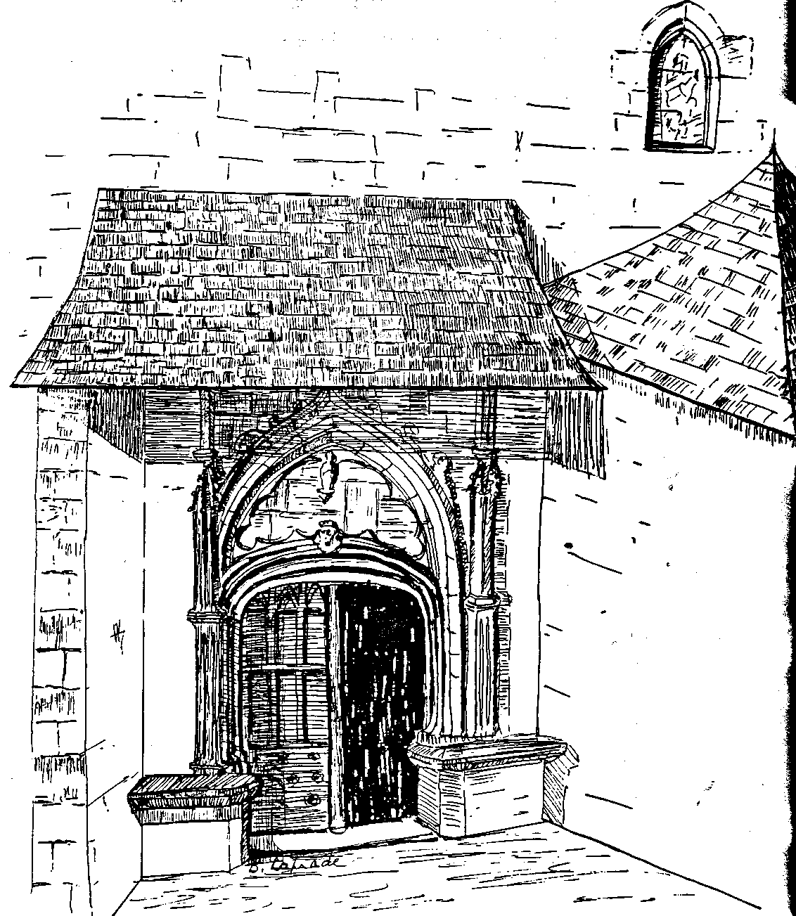
Test reconstitution of the side door of the church before work of enlarging

19
On November 13, 1517, Doat d' Abadie, Johannet de la Guerre, jurats, accompanied by Johan de Puts priest, as a delegation went to the bishop of Lescar to obtain the recognition of the foundation of the brotherhood Sainte Catherines in Montaut and it is hard to imagine that this brotherhood did not have an altar and a chapel already built in the church.
In the plaque which consecrates our church, Leonce Peyrègne quotes the date at 1426 found on the unique keystone no history of the sanctuaire which was refuted in 1941 by an architect of the historic buildings, that he estimated in contradiction with the files.
Then where was this church Saint Antoine which is mentioned, on several occasions in the writings of XV century?
The question remains posed. Can one say nevertheless that Jean de Puts, priest of Montaut, already in 1492 and for more than fifty years, founder of the Brotherhood of Saint Catherine and a rich landowner considered the constructor (or the installation) of a church in the center of the village, already on existing architectural elements?
According to the abbot Bonnecaze , Jean de Puts provided himself in Court with Rome to have the title of perpetual priest (hitherto he had only the title of perpetual vicar). He obtained his request, but the Benedictines disputed him, and pled in front of the sovereign council of Pau.
De Puts won and was maintained. In order to ensure his subsistence, he obtained abbey grounds.
The construction or modifications was not completed because of his death, undoubtedly for lack of average materials, in 1547 and it is undoubtedly his successor Pées de Guilhem-Péré who completed the building, about 1550-1555. Dedicated to the hermit Saint Antoine, the church preserved this patronym until the destruction of the chapel of Saint Hilaire de Lassun by the troops of Montgommery in 1569.
Between two buttresses of the church one builds the “judicial court “¹⁰ the ancestor of our” Town hall “the place where the jurats met to judge businesses of the community but which could also serve as” prison “.
In 1546, the enumeration for the levy of the tailles, listed 45 fires.

The chapel Saint Jean
Rare are our fellow-citizens who remember the existence of this chapel. Several authors and even a chart, make reference to it. One of them described it as follows: It has there a chapel dedicated to Saint Jean Baptiste located on a height in the sugar loaf shape where they go in procession on the day of the Saint Jeant and there is held a mass from time to time, It is on an eminence which forms sugar loaf. He adds with humour: the inhabitants have piety and religion. There are heretics!
Of this chapel, there remain only some stones in the middle of a bramble bush.

Chronique de Montaut

20

The first “land measure” of Montaut
September 1581, for fiscal reasons (the perception of the tax) one asks the jurats, the land measure of Montaut, i.e. the document counting the surface of each parcel of the community and indicating the name of its owner.
Such a document does not exist, at that time; an order is given to measure the territory in perche (old French surveying unit). Naming indicators to show the limits.¹²
Thus we have the first census-land measure of our commune which goes back to the year 1583¹³. It acts as a working tool of first importance in the field of historical research.

A disagreement between Montaut and Saint Pée
The establishment of the land measure seems to have left uncertain pieces bordering on neighboring Bigorre, a source of dispute with our neighbors.
An extract of the Register of the Chamber of Accounts of Pau informs us more precisely:.
The inhabitants of the place of Montaut and those of the town of Saint Pée de Geyres, in Bigorre, by the tolerance of the officers of His Majesty, have commonly enjoyed the undivided pasture for their cattle and other conveniences in the territory located between the places known as Montaut and Saint Pée, a lawsuit having been driven against them, for the renunciation of the usage, as to make them condemn in apologies and payment, the princess Catherine, sister of the King, in consequence of all the above decided to make them lease and on October 25, 1585 made them pay affièvement for the grounds, fruits and usage enjoyed by them and their joint successors undivided, while paying by each per year, the following: those of Saint Pée 27 livres 2 sols 6 deniers and those of Montaut, a similar sum; for lease and affièvement verified on December 12, 1586.”

Wars of religion
Jeanne d' Albret, a dedicated Protestant woman, had married Antoine of Bourbon, father of the future Henri IV, and good catholic. When her husband was alive he did not undertake an action of scale against those.
Antoine of Bourbon, died, of a coup d’arquebus in the siege of Rouen on November 17, 1562.
His wife, free of her movements, wrote then to Calvin to ask him to send “ministers to her”. He sent to her ten men in spring of 1563. At their head, Jean Merlin who was the heart of the reformation in Béarn.
Under her influence, the queen prohibited the processions in certain places, stripped the churches and at the protestant synod held in Pau the same year, she imposed on the clergy a contribution of 15.000 livres for the maintenance of the “ministers”, confiscated the sacred vessels and multiplied the obstacles to the freedom of catholic worship.

Chronique de Montaut
21
One finds in XVI century the mention of the ham of Bayonne, manufactured as well in the pays basque in Béarn.
“Salted goose” was a speciality of the béarnaise. Henri IV wrote to the governor of La Force: I ask you to send to me a dozen geese salted of Béarn, the fattest that you will be able to recover, so that they honor the pays. He also asked, whereas he was encamped in front of La Rochelle that one sends a dozen Basque hams to him, for the price of 143 livres.
NOTES
- ADPA E360.
- ADPAB806f°102sq.
- ADPA Montaut CC1
- H.Lassalle op.cit. page 247
- ADPAD806f°102sq.
- L.Peyrègne the bastide of Montaut and its church Saint Hilaire Pau 1977 V.Allègre old churches of Béarn.H.Lassalle op.cit; page 204.
- Directory of Saint Pée 1884 page 541. “With the front of the church and chapel of Saint Antoine located on the place of the aforesaid place of Montaut, usual place of the meetings”.
- ADPA E 1204v.
- L.Peyrègne op.cité, page 12.
- A visit of the roofs of the sides of the current building makes it possible to realize, still today perfectly, the site of this room.
- On the charts of Roussel and Cassini (XVIII century) figure well the chapel, not under the term of Jean Saint, but under that of Saint Pierre
- ADPA Montaut CC1
- ADPA Montaut CC1
- Directory Saint Pee page 563
- ADPAE289f°10et11.
- This right of course will give place to future disputes on November 19, 1654 ADPA Montaut FF1, with request at the Parliament.
- ADPA E 1715
- ADPAB5962.
Chronique de Montaut

